Table of Contents

Section 1: Glycogen Metabolism
1. Glycogen Phosphorylation and Substrates
2. Glycogen Regulation
3. Glycogen Autophagy

Section 2: Pentose Phosphate Pathway

Section 3: Lipid Metabolism
1. Fatty Acid Catabolism
2. Fatty Acid Synthesis
3. Polyketide Pathway
4. Regulation of Lipid Synthesis
5. Sterol Synthesis and the Isoprenoid Pathway
6. Miscellaneous Topics

Unit 4: Core Metabolism II

Section 1: Glycogen Metabolism (see any standard biochemistry textbook for a description of the enzymes and basic reactions)
1. Glycogen Phosphorylation and Substrates: Although most biochemistry textbooks do a good job covering the basic reactions in glycogen synthesis and degradation, there are two topics scarcely mentioned: glycogen phosphorylation and substrates. Glycogen contains 0.05-0.1% phosphate; the phosphate is located on the third and sixth carbons of glucose. Originally, the phosphate was thought to originate from the β-phosphate in UDP-glucose as a catalytic error by the glycogen synthase. It is now known that the phosphorylation is performed by separate kinases.

The function in glycogen is unknown but more information on this process is available for starch. Starch and glycogen have identical structures: a glucose polymer with α1,4 linkage and α1,6 branching. The only difference is the frequency of branching: in glycogen, a branching node occurs about every 10 residues; in starch, the nodes occur every 20-25 sugars. In starch, an α-glucan, water dikinase transfers the γ-phosphate of ATP to water and the β-phosphate to the C6 of glucose. This phosphate helps to hydrate the surface of the starch particle. Then a phosphoglucan, water dikinase phosphorylates the C3 of glucose to disrupt helical packing and to block recrystallization. These phosphorylations make starch more accessible to degradation; however, ironically as long as the phosphates are in place, they will block the access of starch degrading enzymes. The phosphates must first be removed by the phosphoglucan phosphatase. In humans, deficiency of this phosphatase results in the accumulation of phosphate and poorly branched glycogen with abnormal morphology. Clinical symptoms include epilepsy, neurodegeneration, and death. This condition is known as Lafora disease after the name of the person who first described it, Gonzalo Rodriguez Lafora; and the phosphatase is called laforin. Laforin also acts as a glycogen localization subunit for malin, an E3 ligase that targets glycogen synthase (see below).

Most textbooks show glucose as the sole substrate for the enzymes of glycogen metabolism. However, they can also utilize glucosamine. About 0.1% of liver glycogen is glucosamine; muscle, 1%; and brain, 25%. It is suspected that cellular levels of glucose and glucosamine determine the ratio in glycogen from different tissues. In brain, the glucosamine is important in the glycosylation of proteins, which is probably why the symptoms in Lafora disease are predominantly neurological.

2. Glycogen Regulation: Glycogen is a glucose reservoir; glycogenolysis also acts to buffer inorganic phosphate during high ATP utilization, such as occurs in muscle and nervous tissue. This buffering maximizes the energy yields from ATP. As such, glycogen metabolism will be affected by the energy status of the cell: low energy will trigger glycogen breakdown to mobilize glucose for oxidation, while high energy will favor glycogen synthesis to store unneeded glucose (Table 1). As with any reaction, substrates will drive glycogen synthesis. Finally, in muscle, calcium elevation signals contraction and energy depletion; calcium will also stimulate glycogenolysis in order to replenish energy reserves.

Table 1. Factors Affecting Glycogen Metabolism
Modifiers | Favor Glycogen Synthesis | Favor Glycogenolysis
Substrate | Glucose-6-phosphate
Energy | High: ATP, AcCoA (direct  and via acetylation | Low: ADP, AMP, P_{i}, NAD⁺
Anticipation |  | Ca²⁺ (contraction)

a. Glycogen Synthase: A schematic diagram of glycogen metabolism is shown in Fig. 4-1. Glycogen synthase is phosphorylated by many kinases: e.g., glucagon and epinephrine are secreted during fasting and activate PKA to phosphorylate glycogen synthase. This actually has no immediate effect on its activity, but rather primes the enzyme for subsequent kinases. For example, casein kinase requires a negative charge adjacent to its phosphorylation site; and the phosphate attached by PKA provides this negative charge. The effects of PKA, glycogen synthase kinase 3 (GSK3), AMPK, and other kinases are additive; that is, the enzymatic activity of glycogen synthase is not just “on” or “off”, but can be fine-tuned (represented by the multiple arrows in Fig. 4-1).

Fig. 4-1. The Regulation of Glycogen Metabolism. Abbreviations: G, glycogen; GS, glycogen synthase; Inh-1, inhibitor-1; Ph, glycogen phosphorylase; PhK, glycogen phosphorylase kinase; PP, protein phosphatase; Ub, ubiquitin. Green, allosteric activators; red, allosteric inhibitors; pointed arrows, stimulation or substrate flow; flat arrows, inhibition; bold font, core pathway. See text for details.

Glycogen synthase can also be regulated allosterically: it is activated by glucose-6-phosphate (substrate) and inhibited by ADP and inorganic phosphate (low energy). Energy status can be further conveyed by acetylation: high acetyl CoA drives the acetylation and inhibition of GSK3. The acetylated GSK3 cannot phosphorylate and inhibit glycogen synthase, because when there is abundant energy, the body wants to store the excess glucose. However, when energy levels are low, NAD⁺ is elevated and stimulates SIRT to deacetylate and reactivate GSK3. Another energy input comes from AMPK: when energy levels are low, AMPK is activated and phosphorylates laforin. This covalent modification induces the association of laforin with malin, an E3 ligase. The laforin acts as a glycogen localizing subunit and brings malin to the glycogen particle where it ubiquitinates glycogen synthase. This destruction is enhanced by PKA, which is also elevated during starvation and which can phosphorylate and stimulate the proteasome. Although the proteasome can degrade any ubiquinated protein, more often than not anabolic enzymes, like glycogen synthase, are targeted for ubiquination.

b. Glycogen Phosphorylase: Glycogen phosphorylase is also tightly regu-lated; indeed, it is the rate-limiting step in glycogen breakdown. The phosphorylase can exist as either a dimer (phosphorylase b) or a tetramer (phosphorylase a). The dimer is under allosteric control: AMP (low energy) stimulates it to release glucose for oxidation, while G-6-P (product derived from G-1-P) inhibits it. Phosphorylation by the glycogen phosphorylase kinase (PhK) converts the dimer to the tetramer, which is fully active and independent of any allosteric regulation. High acetyl CoA drives the acetylation of phosphorylase a and this acetylation recruits protein phosphatase 1 (PP1). PP1 dephosphorylates the tetramer and converts it back to the dimer. However, low energy elevates NAD⁺ which activates the deacetylase, SIRT. There are also several tissue-specific controls. In the brain, which is particularly vulnerable to ROS, oxidation generates a disulfide bond that renders the glycogen phosphorylase insensitive to AMP but not phosphorylation. Presumably this reduces the amount of glucose available for oxidation, which then reduces the amount of ROS generated by the etc. Conversely, during hypoxia phosphoglycerate kinase, normally a glycolytic enzyme, phosphorylates and activates glycogen phosphorylase in order to release glucose for energy production. In T lymphocytes, interleukin-2 (IL-2) stimulates proliferation, which requires glucose. The effects of IL-2 are mediated, in part, by the small G protein, Rac1, which binds and allosterically stimulates the glycogen phosphorylase.

Glycogen PhK is also subject to regulation. This kinase has four copies of four different subunits (αβδγ)₄: the γ subunit contains the catalytic site; the α and β subunits contain regulatory phosphorylation sites; and the δ subunit is the calcium-binding protein, calmodulin (CaM). Phosphorylation of the α and β subunits by PKA increases the activity of the kinase, while calcium binding to the δ subunit has the same action. There is also a steep temperature curve: enzymatic activity gradually rises between 10 and 30 C but then dramatically increases between 30 and 40 C. This phenomenon releases glucose during periods of increased energy demand, as during exercise or fever. Finally, as with glycogen phospho-rylase, there is tissue-specific regulation: during muscle contraction, troponin becomes exposed and binds and stimulates glycogen PhK, even when the PhK is unphosphorylated.

Although glycogen PhK has always been considered a dedicated kinase (i.e., a kinase with only one substrate), it has recently been shown to phosphorylate and inhibit glycogen synthase. Although this activity makes sense because the two enzymes have antagonistic actions, this activity has not yet been shown to occur physiologically.

c. Inhibitor-1: All of the above is for nought, if phosphatases remove phosphates as quickly as they are attached. Indeed, phosphatases are 100-1000 times more active than kinases; this is designed to keep basal activity within the cell low. Therefore, any activation of a kinase is usually accompanied by the inhibition of phosphatases. One of the major phosphatases in glycogen metabolism is protein phosphatase-1 (PP-1). During starvation, glucagon and epinephrine stimulate PKA via the elevation of cAMP. PKA phosphorylates and primes glycogen synthase for subsequent inhibitory phosphorylations, thereby turning glycogen synthesis off; and PKA phosphorylates and activates glycogen PhK, which then phosphorylates and stimulates glycogen phosphorylase to breakdown glycogen. PP-1 can remove the phosphates from both substrates and terminate glycogen degradation. To prevent that, PKA also phosphorylates inhibitor-1, which then binds and inhibits PP-1. In addition, the ubiquination mechanism that regulates glycogen synthase levels (see above) also applies to PP-1. Specifically, during starvation AMPK phosphorylates laforin, which binds malin and brings it to the glycogen particle. There it ubiquinates both glycogen synthase and PP-1. On the other hand, insulin stimulates glycogen synthesis, in part, through PP-1: it activates S6KII via MAPK (see Integration of Metabolism for details). S6KII will then phosphorylate and stimulate PP-1 to remove the phosphates on glycogen synthase, glycogen phosphorylase, glycogen PhK, and inhibitor-1, resulting in a switch from glycogen breakdown to glycogen synthesis.

3. Glycogen Autophagy: There is a noncanonical pathway for glycogenolysis. It involves autophagy, which is a mechanism to remove unnecessary or dysfunctional cell components via the lysosome. Briefly, the glycogen particle is tagged with the starch-binding domain-containing protein 1 (Stbd1). Stbd1 acts as a glycophagy receptor by binding to the autophagy-related protein 8 (Atg8). Atg8 is embedded in membrane fragments which coalesce around and encapsule the glycogen particle. The resulting glycophagosome fuses with the lysosome and is degraded. This pathway appears to prefer glycogen particles that are larger, less branched and more heavily phosphorylated; such particles are more difficult to digest and may explain why they are shunted into the lysosome.

Regulation of this pathway has not been extensively studied. It is known that AMPK (starvation signal) phosphoylation of Stbd1 improves its binding to Atg8, which favors glycophagosome formation and glycogenolysis. Furthermore, the β-adrenergic pathway (starvation, stress) favors and insulin (anabolic) inhibits this process; but the molecular mechanisms of these hormones are unknown.

Section 2: Pentose Phosphate Pathway (see any standard biochemistry textbook for a description of the enzymes and basic reactions)
Although many biochemistry textbooks present metabolism as a series of discreet, closed pathways, in truth most pathways are porous with multiple entrance and exit points. Nowhere is this truer that the PPP. Indeed, to even call this a pathway at all is a gross exaggeration: it would be more accurate to call it a collection of reactions where substrates ebb and flow, depending upon the needs of the body. There are three broad functions of the PPP: to make NADPH for synthesis and ROS detoxification; to make ribose for nucleotide synthesis; and to take what-ever carbohydrates the organism has and make whatever carbohydrates the organism needs. The latter may be a slight exaggeration, but it emphasizes the versatility of the PPP.

1. Glucose-6-Phosphate Dehydrogenase: Glucose-6-phosphate dehydrogenase (G6PDH) is the first and committed step. It will be regulated by factors related to its functions. First, it is allosterically regulated by NADP⁺/NADPH: NADP⁺ stimulates and NADPH inhibits the enzyme (Fig. 4-2). One of the uses of NADPH is in detoxifying ROS; therefore, cell stress will also influence G6PDH. Cell stress activates a kinase known as ATM: ataxia telangiectasia mutant because the kinase is mutated in the disease, ataxia telangiectasia. ATM phosphorylates p38, a member of the MAPK family, which then phosphorylates hsp27. Hsp27 finally binds to and stimulates G6PDH. Heat shock proteins are usually chaperones; but whether hsp27 acts as a chaperone and stabilizes G6PDH or simply acts allosterically is not known. In plants, another stress-activated kinase, ASK (apoptotic signal regulated kinase) directly phosphorylates and stimulates G6PDH. Acetylation acts at two sites: first, G6PDH can be directly acetylated and inhibited. Second, the glycolytic enzyme, phosphoglucomutase, can be acetylated and inhibited; this latter inhibition results in the backup of 3-PG, a competitive inhibitor of G6PDH. ROS activate SIRT which deacetylates and reactivates G6PDH. Deacetylation of phosphoglucomutase allows 3-PG to be cleared, which further activates G6PDH. Hypoxia represents another stress. Hypoxia leads to the O-GlcNAcylation and stimulation of G6PDH. Finally, the PPP is diurnally regulated; specifically, the PPP and NADPH are highest when the temperature is elevated. Active animals have a body temperature 1-2 C higher than inactive animals. Activity requires more energy, the greatest energy source is oxidation, and more oxidation means more etc-generated ROS by-products that need to be detoxified. The critical enzyme involved with this regulation is probably G6PDH: e.g., turkey red blood cell G6PDH has a temperature optimum of 50 C (normal body temperature is 41 C in turkeys).

Fig. 4-2. Regulation of the Pentose Phosphate Pathway. Colors and symbols are as described in Fig. 4-1. Circled numbers refer to the stoichiometry of the reactions. Abbreviation: pY, tyrosine phosphorylation. See text for details.

Another function for NADPH is in biosynthetic pathways, especially lipid synthesis. The G6PDH is induced by insulin in adipose tissue and by prolactin in the mammary gland. Both hormones stimulate fat synthesis in their respective tissues. Furthermore, insulin activated PKB phosphorylates and stimulates NAD kinase, which converts NAD⁺ to NADP⁺; this increases the supply of NADP⁺ for reduction. In addition, malate dehydrogenase forms a complex with G6PDH and stimulates it. Malate dehydrogenase is part of the citrate shuttle that shuttles acetyl CoA from the mitochondrial matrix, where it is produced, to the cytoplasm, where fatty acid synthesis takes place. Therefore, this enzyme is a signal that fatty synthesis is occurring and NADPH is needed.

Finally, PPP is the source of ribose for nucleotide synthesis. The actions of most growth factors are mediated by tyrosine phosphorylation, either via their own RTKs or, as in this case, through a soluble tyrosine kinase (STK). Src, a STK, phosphorylates and stimulates G6PDH.

Plants have a unique redox regulation of G6PDH. In plants, carbon dioxide is assimilated via the Calvin cycle whose reactions overlap those in the PPP. If both pathways were active at the same time, futile carbon dioxide cycling would occur. To prevent this problem, plant G6PDH has a conserved cysteine which will inhibit enzymatic activity under reducing conditions. Reducing conditions occur during active photosynthesis when NADPH is being synthesized for the reduction of carbon dioxide (i.e., the Calvin cycle). Therefore, the PPP and the Calvin cycle do not run simultaneously.

b. Other Enzymes and Shunts: Several other enzymes in the PPP are regulated. 6-Phosphogluconate dehydrogenase is acetylated and stimulated by growth factors. Again, growth factors need ribose for nucleotide synthesis. Deacetylation is accomplished by HDAC4, not SIRT; so this modification is not affected by NAD⁺ levels. Transketolase is phosphorylated and stimulated by PKB. PKB is involved with sensing amino acid supply (see Translation Regulation in the Nucleic Acids unit). Amino acids are used in the synthesis of nucleotides; if the amino acid supply is insufficient, there is no need for ribose. An active PKB signals that the amino acid supply is adequate for nucleotide synthesis. Finally, several transaldolases are stimulated by ROS via the formation of an oxygen bridge between the ε-amino group of a lysine and the sulfur of a cysteine.

Finally, there is regulation of glucose partitioning between glycolysis and the PPP. It has already been mentioned under glycolysis that insulin stimulates the O-GlcNAcylation and inhibition of PFK1. This impedes glycolysis and shifts glucose into the PPP to make NADPH for fatty acid synthesis. On the other hand, during starvation the organism needs to oxidize glucose for energy. PKA is activated during starvation and phosphorylates and inhibits G6PDH. This slows the PPP and shunts glucose back into glycolysis.

Section 3: Lipid Metabolism (see any standard biochemistry textbook for a description of the enzymes and basic reactions)
1. Fatty Acid Catabolism: Fatty acid catabolism comprises three basic steps: the liberation of the fatty acids from triacylglycerides in the cytoplasmic lipid droplet by lipases; transport of the cytoplasmic fatty acids into the mitochondria; and the oxidation of the fatty acids. Each of these steps is regulated.

a. Lipases: Free fatty acids are irritating; as such, they are esterified to glycerol to neutralize the acid moiety. Glycerol has three hydroxyl groups available to yield triacylglycerol, or more commonly triglyceride. The first, and rate-limiting, step in fatty acid catabolism is the hydrolysis of the ester bond by a series of lipases that act in sequence. The adipose triglyceride lipase (ATGL) removes the first fatty acid and leaves behind diacylglyceride. First, it is induced by cortisol, the third member of the stress/hypoglycemia triad of hormones. The first two, epinephrine and glucagon, have already been mentioned; many of their effects are mediated by cAMP (see Integration of Metabolism for details). Cortisol is a steroid and acts by gene induction. The general term for this steroid family is “glucocorticoids”; cortisol is the major glucocorticoid in humans, while corticosterone is the main glucocorticoid in rodents. ATGL is also phosphorylated and activated by PKA (glucagon and epinephrine synergism) and AMPK (low energy input). PKA can also phosphorylate perilipins; perilipins are components of the membrane surrounding the lipid droplet. This phosphorylation has two effects. First, the phosphorylated site binds CGI-58, an ATGL coactivator. Second, perilipins sequester and inhibit aquaporin 7, a glycerol channel that allows glycerol to be exported. Perilipin phosphorylation releases this channel. Conversely, G0/G1 switch gene 2 (G0S2) is an ATGL inhibitor that is induced by insulin and repressed by epinephrine. Insulin is the major anabolic hormone of the body and stimulates lipogenesis, while inhibiting lipolysis. G0S2 is used primarily for long-term regulation. Finally, glucose itself represents energy status and can also inhibit ATGL. Briefly, glucose is metabolized to generate ATP, which then blocks ATP-dependent potassium channels leading to depolarization and calcium influx. Calcium activates PKC which stimulates phosphatidylinositol-4 kinase. Although the simplest mechanism for the latter would be direct phosphorylation of the enzyme by PKC, that has not yet been demonstrated. This enzyme elevates phosphatidylinositol-4-phosphate (PI4P), which is critical for the formation of an E3 ligase complex that targets ATGL. The polyubiquinated ATGL is degraded and lipolysis is impaired:

glucose ↑ATP block K_{ATP} channels depolarization calcium

influx ↑PKC ↑PI4 kinase ↑PI4P E3 ligase complex

formation ATGL polyubiquination ATGL degradation ↓lipolysis

The hormone-sensitive lipase (HSL) removes the second fatty acid and leaves behind monoglyceride. HSL is stimulated by PKA phosphorylation and induced by growth hormone. This latter effect may seem confusing as growth hormone is considered anabolic. However, the effect by growth hormone only occurs during fasting and is intended to spare proteolysis by providing an alternate fuel source. In the corpus luteum of the ovary, AMPK phosphorylates a different site to inhibit HSL. This blocks the release of cholesterol from cholesterol esters, which, in turn, inhibits steroidogenesis. This, in part, is responsible for the suppression of reproductive function during starvation.

The last fatty acid is released by the monoglyceride lipase. This enzyme has high, constitutive activity and is not known to be regulated.

b. Mitochondrial Importation: Triglycerides are stored in a lipid droplet in the cytoplasm but are oxidized in the mitochondria. This is a two-step process: activation and transport. Activation refers to the attachment of coenzyme A to the free fatty acid. This is performed by four acyl-CoA synthetases: the short-chain, medium-chain, long-chain, and very-long-chain acyl-CoA synthetases. Some of these enzymes are stimulated by PKA phosphorylation (low energy) and inhibited by acetylation (high energy). The hepatic long-chain acyl-CoA synthetase is also necessary for the expression of several enzymes involved with bile acid synthesis. As bile acids accumulate, they bind and activate the farnesoid X receptor (FXR), a transcription factor that feeds back to repress the expression of the long-chain acyl-CoA synthetase.

The fatty acyl-CoA has to be transferred to carnitine by the carnithine palmitoyl transferase I, imported into the mitochondria via the carnitine carrier, and then released by the carnithine palmitoyl transferase II. Transferase I is allosterically inhibited by malonyl CoA. Malonyl CoA is the product of the first, and committed step, in fatty acid synthesis; as such, it signals active lipogenesis and this control prevents fatty acid synthesis and degradation from occurring simultaneously. The effect of acetylation depends on location: in the liver, acetylation signals energy and inhibits the carnitine carrier to thwart the transfer of fatty acids for oxidation. However, the heart is always in need of energy, and acetylation has a different significance. In this organ acetylation stimulates transferase I. The reader will recall that a similar situation exists with PDH and O-GlcNAcylation; this latter modification is also normally associated with high energy and inhibits many catabolic pathways. However, in the heart O-GlcNAcylation may signal lactate availability and stimulates the PDH. Finally, S-nitrosylation inhibits the carnitine carrier. NO probably signals ROS; and it reduces the flow of fatty acids into the mitochondria to restrict the production of ROS by the etc.

c. Fatty Acid Degradation: The degradation of fatty acids involves the iteration of four simple steps: the introduction of a double bond between C2 and C3 (acyl CoA dehydrogenases); the addition of water across that double bond (enoyl-CoA hydratase); oxidation of the hydroxyl group to a ketone (3-L-hydroxyacyl-CoA dehydrogenase); and the splitting off of acetyl CoA (β-ketoacyl CoA thiolase).

The major sites of regulation are the dehydrogenases; there are four, each specific for a range of fatty acyl CoA lengths. First, many of these enzymes are induced by PKA (low energy). On the other hand, they are inhibited by acetylation (high energy) except in the heart, where acetylation is stimulatory (cf. the acetylation of carnithine palmitoyl transferase I above). Leptin is a hormone that induces a negative energy balance by inhibiting appetite and increasing fatty acid degradation. Leptin action on the latter is mediated by nitric oxide, which leptin induces. NO S-nitrosylates and activates the very long chain acyl CoA dehydrogenase.

d. Degradation of Nonstandard Carbon Chains. Most biochemistry textbooks cover fatty acids with an odd number of carbons or with double bonds. This section will briefly cover the degradation of phytol for several reasons: first, it shows how branched fatty acids are broken down; second, the inability to degrade phytenic acid (a derivative of phytol) is the basis for a genetic disease (Refsum disease); and third, several of the reactions take place in the peroxisome.

Phytol is a product of the isoprenoid pathway (to be covered below) and is attached to chlorophyll. Humans cannot liberate the phytol from the chlorophyll in plant material they eat; but ruminants can and then store it in their fat. It enters humans primarily via ruminant products. Phytol is a long-chain alcohol; it is progressively oxidized to phytenic acid and then activated by attaching it to coenzyme A (Fig. 4-3; note that this is an
abbreviated pathway; several steps are combined for simplicity). At this point one might think that the molecule would enter the mitochondrion and be degraded like any fatty acid. However, the methyl groups are on every other odd-numbered carbon and prevent those carbons from being oxidized to carboxylic acids. Therefore, the chain enters the peroxisome where C-1 is removed as formyl CoA. This is called α oxidation as compared to the removal of acetyl CoA in the mitochondria, which is called β oxidation. What was C-2 (now the new C-1) is progressively oxidized from an aldehyde (pristanal) to an acid and coupled to coenzyme A (pristanoyl CoA). We are back where we started except that now the methyl groups are on every other even-numbered carbon and will not interfere with degradation.

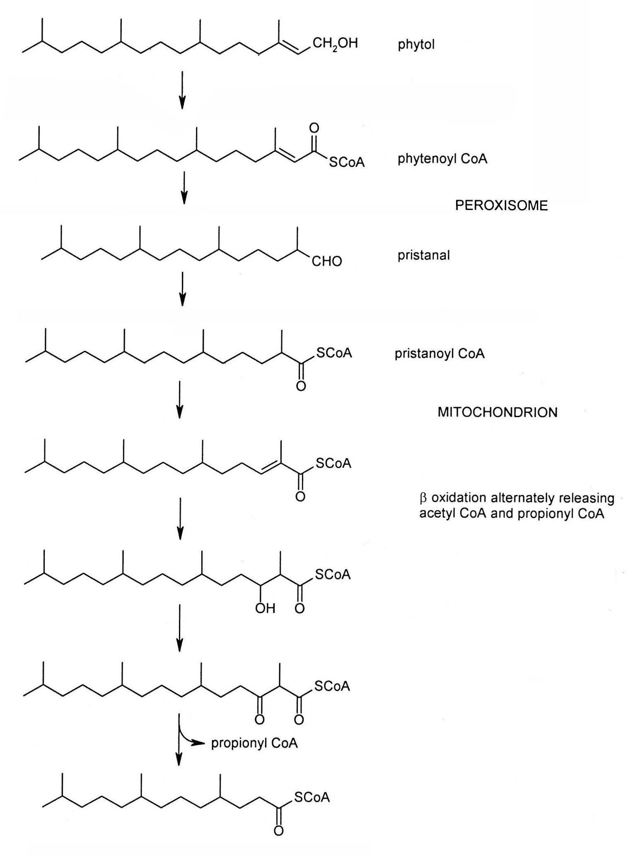
Fig. 4-3. The Degradation of Phytol. This is an
abbreviated pathway; several steps are combined for simplicity.

Peroxisomes were named for their ability to detoxify hydrogen peroxide; however, they serve a variety of functions. As noted above, they can perform α oxidation of fatty acids. They can also perform β oxidation of very long fatty acids: 26 carbons or longer. Once the fatty acid has been shortened, the peroxisome can either continue the degradation or the shorter fatty acid can be transferred to the mitochondrion to complete the process. Finally, peroxisomes are involved with plasmalogen synthesis (to be discussed below). Briefly, a plasmalogen is a membrane phosphoglyceride with a long chain, unsaturated alcohol in the first position instead of a fatty acid. It is the peroxisome that reduces the acyl CoA to an alcohol and attaches it to DHAP before transferring it to the endoplasmic reticulum to finish the synthesis.

In the case of phytol degradation, once the peroxisome has generated the pristanoyl CoA, it is transferred to the mitochondrion to complete its breakdown. Because the cleavage occurs just behind the methyl side chain and because there is a methyl side chain on every other even-numbered carbon, β oxidation will alternately release acetyl CoA and propionyl CoA. The latter is converted to succinyl CoA and is covered in standard texts under oxidation of fatty acids with an odd number of carbons.

In Refsum disease the enzyme that converts phytenic acid to phytenoyl CoA is defective. As a result, phytenic acid accumulates in the nervous system and damages white matter. Symptoms often begin with night blindness and progress to anosmia (inability to smell), deafness, ataxia, etc. Treatment consists of a strict diet low in phytol derivatives.

2. Fatty Acid Synthesis: Fatty acid synthesis occurs in the cytosol of adipose tissue, liver, and the mammary gland in animals. In plants, it occurs in the chloroplasts. In animals, the lipid droplet is associated with special mitochondria that have twice the ATP generating capacity and that are recruited by perilipin5. These mitochondria supply the ATP for triglyceride synthesis; fatty acids must be coupled to coenzyme A before esterification with glycerol and this reaction requires the equivalent of two ATP per fatty acid. This association is completely reversible: the mitochondria dissociate under lipolytic conditions.

The mitochondria do have an abbreviated system of fatty acid synthesis: they perform the same basic reactions as those in the cytosol, but the enzymes are separate, not fused. In addition, they can only synthesize fatty acids up to C14. The longer chains are required by chaperones for complex I assembly, while octanoic acid is used to synthesize lipoic acid. Lipoic acid is a coenzyme for four mitochondrial enzymes and one bacterial enzyme: PDH (bridge between glycolysis and the TCA cycle), αKGDH (TCA cycle), branched chain α-ketoacid (oxoacid) dehydrogenase and the glycine cleavage complex (amino acid degradation), and acetoin dehydrogenase (bacteria). Lipoic acid is actually synthesized on the first two enzymes: first, octanoic acid is attached to the enzymes and then the sulfurs are added to the octanoic acid.

a. Acetyl CoA Carboxylase: The first and committed step in fatty acid synthesis is the acetyl CoA carboxylase (ACC):

ATP ADP+P_{i}

H₃CCOSCoA + HCO₃¯ ─────────── HOOCCH₂COSCoA
acetyl CoA biotin malonyl CoA

There are several types of regulation for ACC: acyl CoA allosterically inhibits it (product inhibition), as does PKA and AMPK phosphorylation (low energy). When energy levels are low, the cell needs to tap into its energy reservoirs, such as fat; therefore, lipolysis will be stimulated (see lipases above), while fatty acid synthesis is inhibited. Conversely, when energy levels are high, the TCA cycle is shut down and citrate/isocitrate accumulate. Indeed, citrate will leave the mitochondria and in the process shuttle acetyl CoA to the cytosol (see Citrate Shuttle below). Therefore, citrate and isocitrate signal both an excess of energy and an abundance of raw material for fatty acid synthesis (acetyl CoA). Citrate and isocitrate trigger the polymerization of the inactive dimer into an active filament (called a run-on oligomer) of 5-10 million daltons. Finally, fatty acid synthesis in the mammary gland is coordinated with milk production. As such, the gene for ACC is induced by prolactin, a pituitary hormone that stimulates milk production in these glands.

Plants have two types of ACC: a homomeric ACC found in the cytosol and a heteromeric ACC in the chloroplast. The former is the same as that found in animals; the latter is found in prokaryotes and chloroplasts. The latter is composed of four different subunits: biotin carboxylase which charges the biotin with the carboxyl group, biotin carboxyl carrier protein, and the α and β subunits of the carboxyltransferase which transfers the carboxyl group from the biotin to the acetyl CoA. The eukaryotic ACC also contains these activities, but they are fused into a single, large protein. Fatty acid synthesis requires hydrogens, which in plants arises from water split during photosynthesis. As such, the chloroplast ACC is coordinated with photosynthesis. First, light induces the ACC gene. Second, light activates an as yet unidentified kinase that phosphorylates and stimulates the enzyme. Third, the carboxyltransferase has a cysteine sensitive to the redox status of it environment. It is also regulated by substrate availability through PII. PII is an ancient bacterial and plant protein that coordinates nitrogen, carbon and energy metabolism. PII inhibits ACC via protein-protein interactions and this association is disrupted by pyruvate. As pyruvate is the source of acetyl CoA, its presence signals adequate substrate for fatty acid synthesis. Finally, like the eukaryotic ACC it is subject to feedback inhibition by acyl CoA.

b. Fatty Acid Synthase: Fatty acid synthesis is nothing more than fatty acid degradation in reverse: condensation (an acetyl CoA displacing the end carboxyl group of malonyl CoA to form acetoacetyl CoA); reduction of the carbonyl to a hydroxyl group; removal of the hydroxyl group as water and leaving a double bond behind; and saturation of the double bond. This sequence is repeated until palmitic acid is formed, at which point it is cleaved from the enzyme. During evolution all of the enzymes catalyzing these reactions have fused into a single fatty acid synthase (FAS).

Elevated levels of acetyl CoA can drive the nonenzymatic acetylation of FAS to enhance its activity (feed forward). However, the major regulation of FAS is via transcription. In adipose tissue, glucose (high energy, substrate) induces and AMPK (low energy) represses gene expression. In the mammary gland, the FAS gene is induced by prolactin. In the liver, insulin (anabolic hormone) induces a protein known as the thyroid hormone responsive protein spot 14, which stimulates FAS activity by 50%.

c. Palmitic Acid Modifications: FAS only makes palmitic acid, a satu-rated, 16-carbon fatty acid. All other fatty acids are synthesized from this fatty acid. For longer fatty acids, palmitic acid is transferred to the endoplasmic reticulum and subject to the same four reactions: condensation with malonyl CoA, reduction of the ketone, dehydration, and reduction of the double bond. There are several differences; first, the enzymes are separate and not fused as in FAS. Second, the first enzyme, fatty acid elongase, has seven isozymes, which differ in substrate specificity (acyl CoA length and saturation) and tissue distribution. The other three enzymes are the same. Finally, there is a fifth protein that measures the length of fatty acids. Fatty acid elongation can also occur in mitochondria. However, the acyl CoA is joined to the back of acetyl CoA, not malonyl CoA; and one NADH and one NADPH are consumed. Shorter fatty acids are made by paring back palmitic acid.

The rate-limiting step in desaturation is the stearoyl CoA desaturase. It is induced by insulin and saturated fatty acids via the transcription factor, sterol response element binding protein (SREBP). Polyunsaturated fatty acids inhibit induction by a different, yet uncharacterized, pathway. Desaturases in the mammary gland are induced by prolactin.

Bacteria can synthesize branched fatty acids; the pathway depends on the location of the methyl side-chain (Fig. 4-4). The pathway for making a fatty acid with a branched tail involves the same four steps, except that the first residue is the derivative of a branched amino acid (Fig. 4-4A). For an internal branch, methylene from S-adenosylmethionine (SAM) is added across a double bond which is then reduced (Fig. 4-4B). Alternatively, one of the bonds can be shifted to the adjacent carbon to create a cyclopropane within the chain.
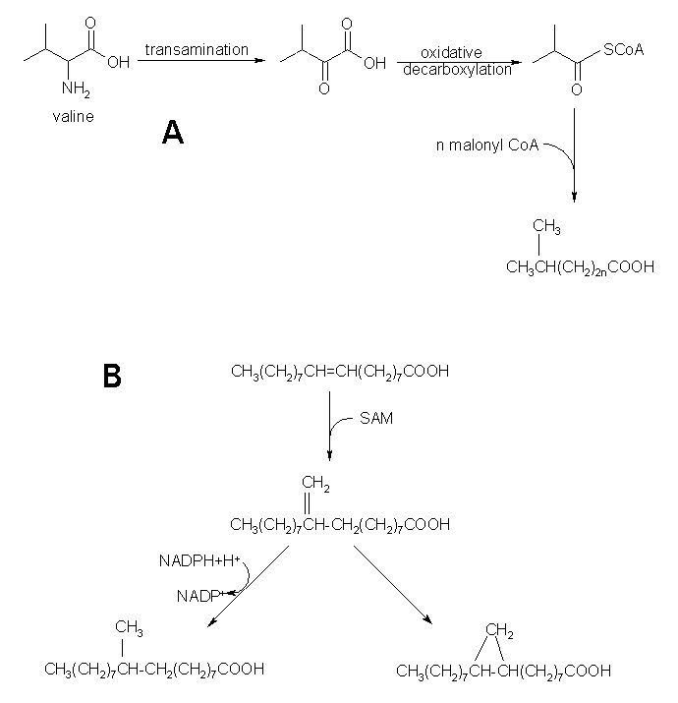

Fig. 4-4. Bacterial Synthesis of Branched Fatty Acids.

d. Citrate Shuttle: Acetyl CoA is made in the mitochondria, but fatty acids are synthesized in the cytoplasm; and there is no membrane carrier for acetyl CoA. This problem is solved by the citrate shuttle (Fig. 4-5). Briefly, acetyl CoA is coupled to OAA to make citrate. There is a carrier for citrate. Once in the cytoplasm, citrate is split back into acetyl CoA and OAA by the ATP-citrate lyase.

Fig. 4-5. The Regulation of the Citrate Shuttle. Abbreviations: BCKD kinase, branched chain keto acid dehydrogenase kinase; G6PDH, glucose-6-phosphate dehydrogenase; GSK3, glycogen synthase 3; OAA, oxaloacetate; PPP, pentose phosphate pathway; TRX, thioredoxin.

The ATP-citrate lyase is the focus of regulation. Acetylation (substrate abundance) stimulates the lyase. Insulin (anabolic hormone) stimulates the lyase in three ways: first, it activates PKB which can directly phosphorylate the lyase. Second, GSK3 was introduced as a kinase that inhibits glycogen synthase. However, it has a large number of substrates, nearly all of which it inhibits; it also has a high constitutive activity. It appears to have the function of maintaining a low basal state during quiescence. GSK3 phosphorylates and inhibits the lyase; and PKB phosphorylates and inhibits GSK3. By inhibiting the inhibitor, lyase activity is derepressed. Finally, insulin induces the branched chain keto acid dehydrogenase (BCKD) kinase. BCKD is an enzyme in amino acid catabolism (see Unit 5); the BCKD kinase phosphorylates and inhibits BCKD and, therefore, amino acid breakdown. BCKD kinase can also phosphorylate and stimulate the lyase. This coupling between amino acid and fatty acid metabolism allows insulin to inhibit amino acid catabolism while it stimulates fatty acid synthesis.

In plants, fatty acid synthesis is dependent upon photosynthesis for the NADPH. The dependence of FAS on the reducing environment created by photosynthesis has already been discussed above. Like the FAS, the lyase is activated by NADPH via thioredoxin (TRX).

There is no carrier for OAA; so it too must be converted into a form that can reenter the mitochondria and be recycled. First, OAA is reduced to malate, which then undergoes an oxidative decarboxylation to pyruvate. The latter enzyme uses NADP⁺ as the hydrogen acceptor; this augments the supply of NADPH for fatty acid synthesis. Furthermore, the former enzyme, malate dehydrogenase, forms a complex with and stimulates G6PDH, the committed step in the PPP, thereby further increasing the supply of NADPH.

3. Polyketide Pathway: Imagine fatty acid synthesis without the reductive steps; i.e., acetyl CoA is condensed with malonyl CoA to form acetoacetyl CoA which is then condensed with another malonyl CoA, etc. The result would be a carbon chain where every other carbon was a ketone; this is the polyketide pathway. It is one of the most versatile pathways in nature and it produces some of the most important drugs in the pharmaceutical armamentarium. Indeed, before actually discussing the pathway, it may be instructive to present a small sampling of products (Fig. 4-6). Antimicrobial compounds are well-represented: tetracycline, erythromycin (the antibiotic of choice for patients with penicillin allergy), and amphotericin B (an antifungal agent). Rifampin is an antituberculosis drug as well as a very useful laboratory reagent. It works by inhibiting transcription initiation but does not interfere with elongation. As such, it can be used to measure transcription rates by freezing initiation and allowing just elongation to be monitored. Rapamycin is also useful at the bedside and in the laboratory. It is an immunosuppressant used in organ transplantation. It worked so well that there was an attempt to discover its mechanism of action so that even better analogs could be developed. It was soon discovered that it acted by binding a cellular protein that became known as the “target of rapamycin” or TOR (mTOR for mammalian TOR). mTOR turned out to be a critical protein kinase which will be discussed extensively in Integration of Metabolism. Rapamycin is used in the laboratory to inhibit mTOR in order to probe its functions. Finally, lovastatin is a cholesterol-lowering drug. The possible combinations and permutations of this pathway are almost endless. Interestingly, a polyketide synthase gene has been identified in some animals and has been shown to be essential for otolith formation in fish. Otoliths are small calcifications in the inner ear of vertebrates; they are involved with the detection of gravity and movement. The product of this enzyme in animals has not yet been identified.

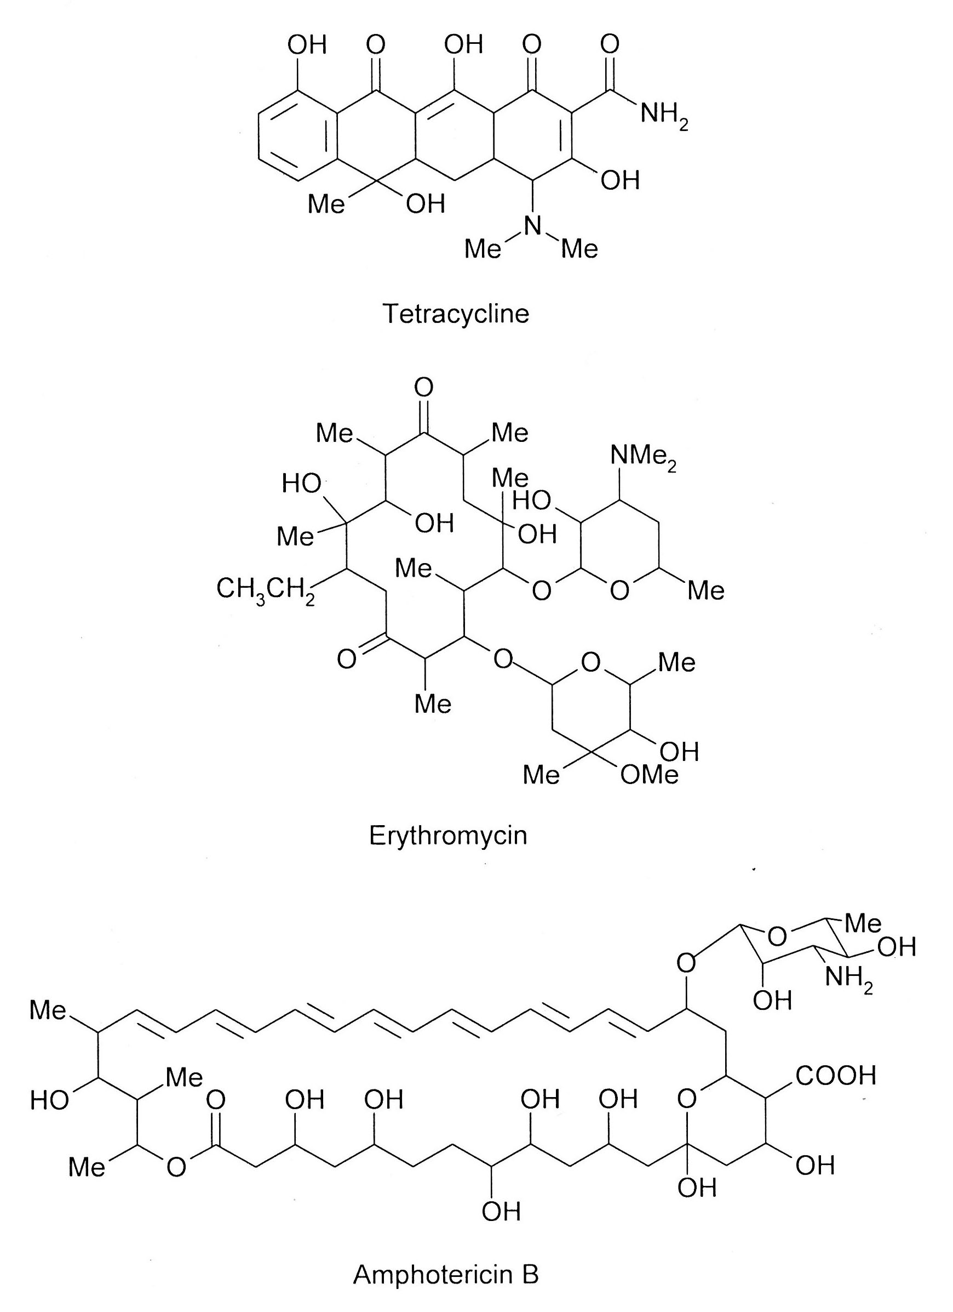

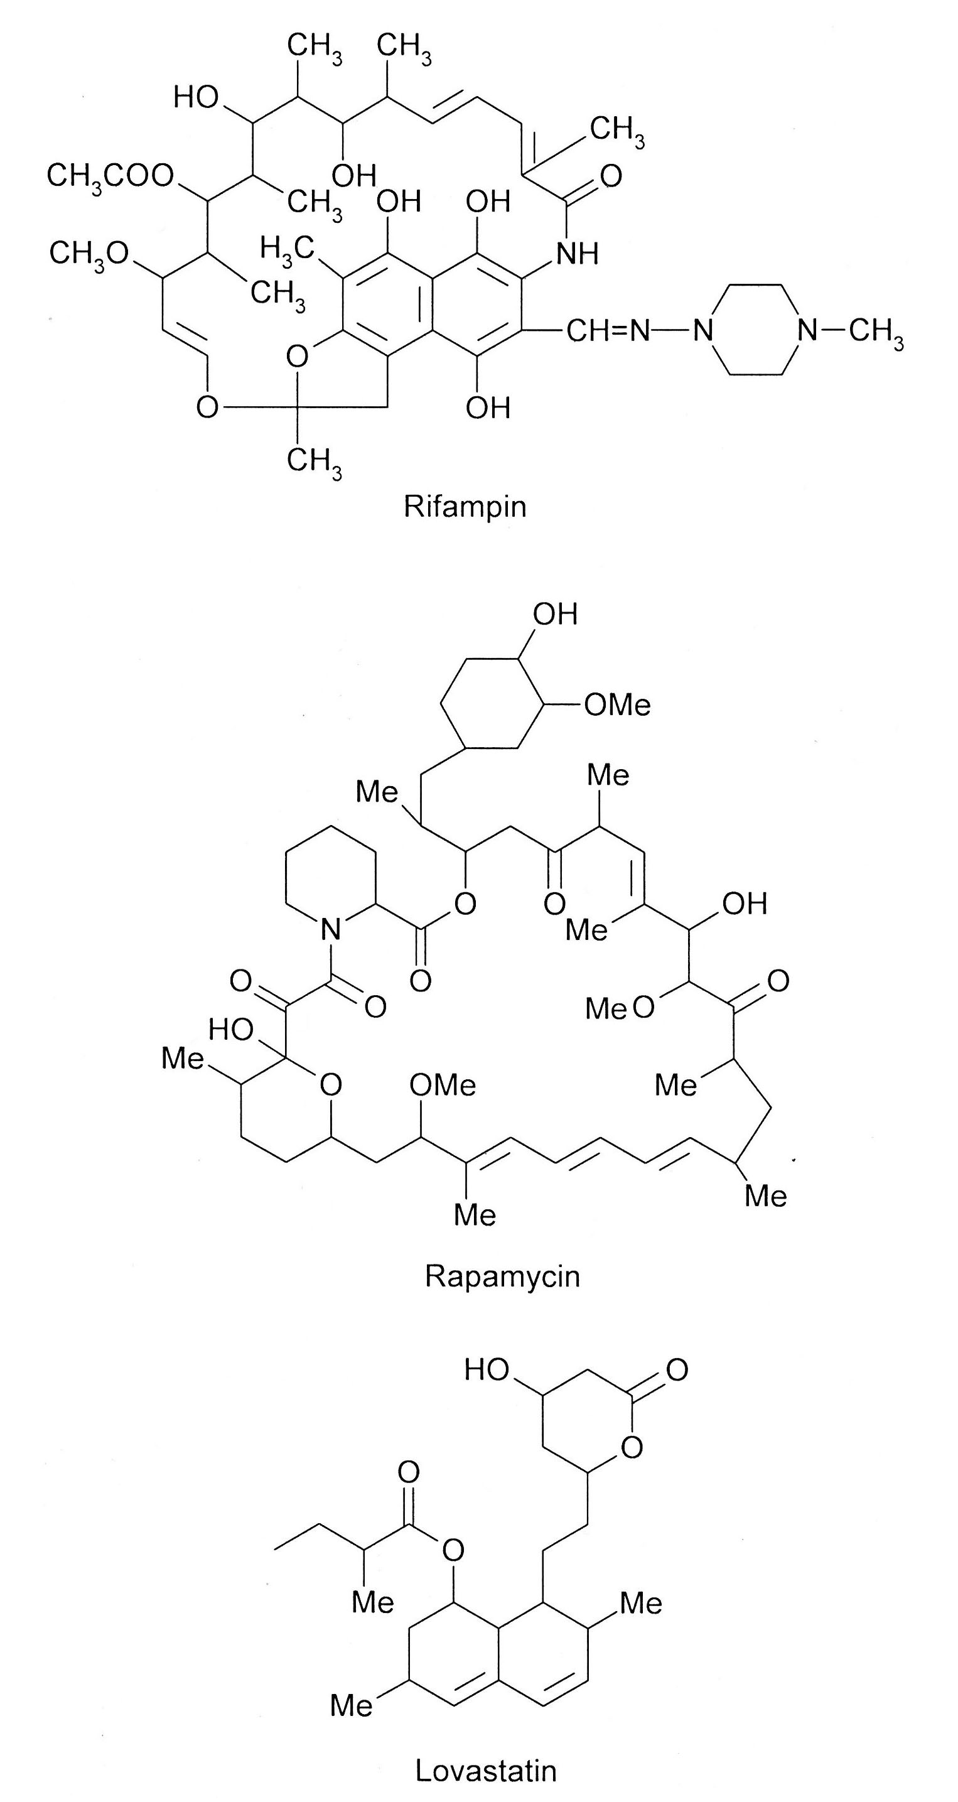
Fig. 4-6. Representative Sampling of Products from the Polyketide Pathway.

How can one get from a simple polyketide chain to such complex, ring structures? A schematic pathway for the synthesis of tetracycline shows how (Fig. 4-7). The first residue is an amidated malonyl CoA; this pathway can use a variety of acyl CoAs as the first residue. Eight successive condensations occur with malonyl CoA, as occurs with fatty acid synthesis but without the reductions. Then the electrons in the carbonyl can be used to close rings. A variety of other modifications can also occur.

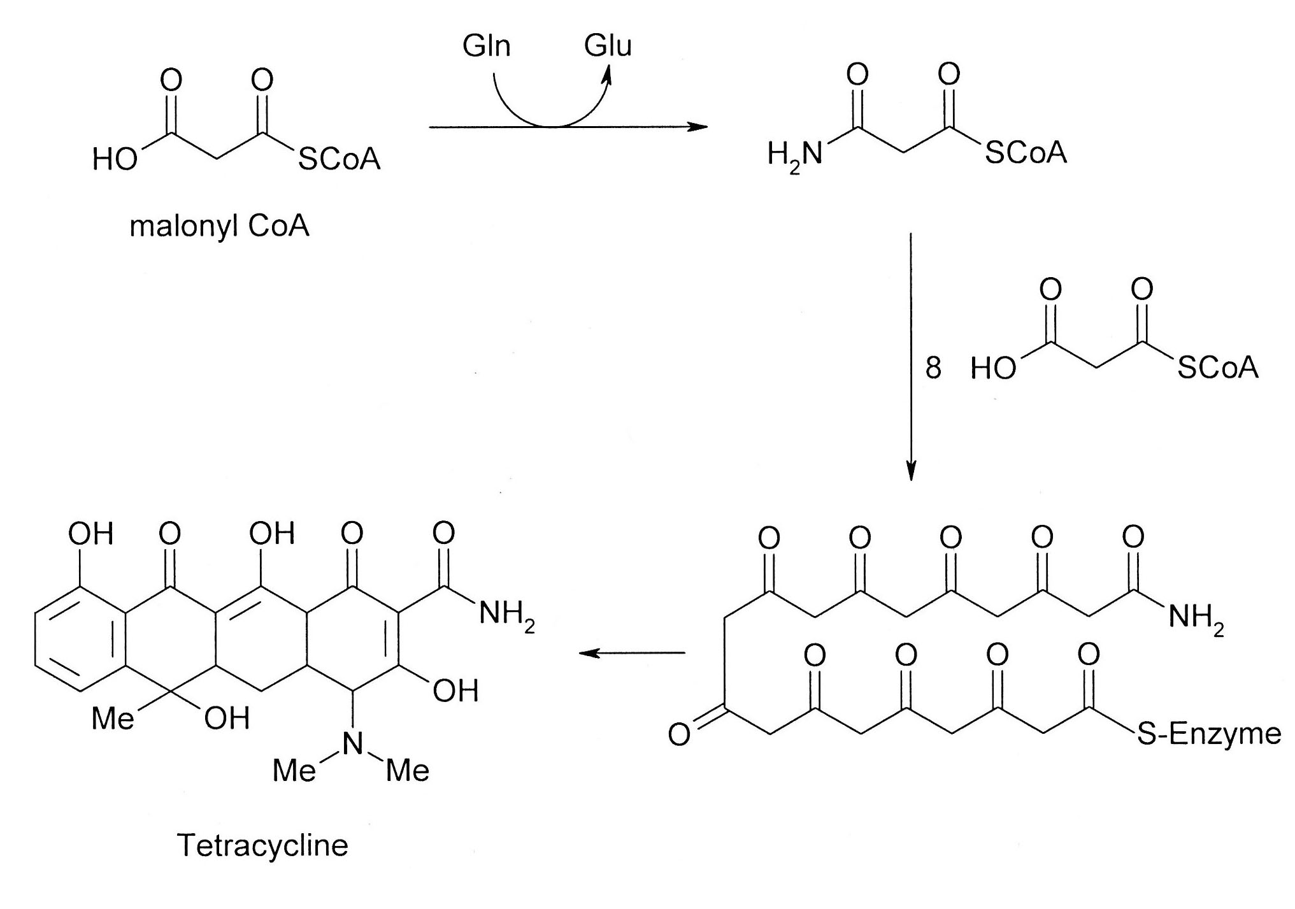
Fig. 4-7. The Schematic Pathway for the Synthesis of Tetracycline.

The synthesis is accomplished by a series of modules, each resembling FAS (Fig. 4-8). Each module can have reductive enzymes depending upon the structure being synthesized: i.e., the chain may have a mixture of keto, hydroxyl, unsaturated, and saturated units. The modules are linked together through coiled coils at their amino and carboxy termini and the growing chain is “handed” from one module to the next. The acyltransferase attaches a (potentially substituted) malonyl CoA to the ACP, while the ketosynthase is loaded with the first acyl group (first module) or the chain from the preceding module (later modules). The latter group then condenses with the malonyl CoA. If reduction is to occur, that module will have additional reducing enzymes that will act on the unit attached to the ACP. If there are a series of identical units, the chain can be retained within the same module for repeated cycles before being passed on to the next module. The last module has a thiolase which releases the chain. Ring closures and other modifications occur elsewhere.

Fig. 4-8. A Typical Module for the Polyketide Pathway. Heavy arrows indicate substrate flow. Once the chain is condensed onto the malonyl CoA attached to the ACP (2), the ACP will shuttle it to the reducing enzymes if present (dotted circles) before transferring it to the next module (6) or the thioesterase for release (last module only).

4. Regulation of Lipid Synthesis (see any standard biochemistry textbook for a description of the enzymes and basic reactions)

Triglycerides are synthesized by attaching fatty acids to phosphoglycerol. The rate-limiting step is the addition of the first fatty acid by the glycerol phosphate acyltransferase; it is regulated by shifting it from the endoplasmic reticulum to the lipid droplet. The control for this migration is not known. It is also inhibited by phosphorylation, although the kinase has not yet been identified. The phosphorylated serines are located close to one another, suggesting a casein kinase-like hierarchical phosphorylation (cf. the phosphorylation of glycogen synthase). Indeed, both glycogen and lipid synthesis would be inhibited during energy mobilization. The next two fatty acids are added by the acyl-CoA:monoacylglycerol transferases and the acyl CoA:diacylglycerol transferase, respectively. These two enzymes exist as a dimer and, therefore, represent substrate channeling. The latter is the committed step and is regulated by transcription. For example, prolactin induces this enzyme in the mammary gland.

Membrane phosphoglycerides branch from the triglyceride pathway after the second fatty acid is attached. Instead of attaching a third fatty acid, a polar head group is added (de novo pathway). Phosphatidylcholine and phosphatidylethanolamine are the two most common phosphoglycerides in the plasma membrane. CTP:phosphoethanolamine cytidylyltransferase is the rate-limiting step in the synthesis of phosphatidylethanolamine by the salvage pathway. The enzyme is induced by growth factors; the enzyme is also stimulated by phosphorylation by PKC, which is frequently activated by growth factors. Choline kinase is the first step in the salvage pathway for phosphatidylcholine; enolase from glycolysis, which provides critical intermediates for growth, binds to choline kinase and protects it from ubiquitination and degradation. Quite simply, proliferating cells need more membrane. Induction is blocked by 25-hydroxycholesterol. This represents feedback inhibition to maintain the proper ratio of membrane lipids. Finally, enzyme activity is inhibited by AMPK: when energy levels are low, fatty acids need to be oxidized to replenish energy levels and not shunted into membrane lipid synthesis. Direct phosphorylation by AMPK has not yet been demonstrated. Indeed, AMPK also inhibits phosphatidylcholine synthesis but has no effect on the CTP:phosphocholine cytidylyltransferase. Rather, AMPK stimulates the oxidation of choline, thereby depleting the supply. However, in plants, the sucrose nonfermenting 1–related protein kinase 1 (SnRK1; an ortholog of AMPK) does directly phosphorylate and inhibit CTP:phosphocholine cytidylyltransferase. In animals, the cytidylyltransferase is also stimulated by phosphatidylcholine-deficient membranes.

The first three steps in plasmalogen synthesis take place in the peroxisome: a fatty acid is transferred from acyl CoA to C1 of DHAP; another acyl CoA is successively reduced to a long-chain alcohol by the fatty acyl CoA reductase 1; and then the fatty acid on DHAP is replaced by the alcohol. The remainder of the pathway takes place in the endoplasmic reticulum. The rate-limiting step is the fatty acyl CoA reductase 1, which is regulated by ethanolamine plasmalogen levels in the inner leaflet of the plasma membrane: when levels are high, the reductase is degraded (product inhibition). The plasmalogen sensor and the mechanism of degradation are unknown.

The rate-limiting step in sphingolipid synthesis is the serine palmitoyl transferase (SPT), which catalyzes the first step (Fig. 4-9). Sphingolipids have a long pathway that utilizes many substrates: e.g., fatty acids, amino acids, etc. Furthermore, many of the products moonlight as signaling molecules, especially in stress. All of this will figure into the regulation of this pathway. SPT is inhibited by Orm1/2, which in turn is regulated by mTOR. mTOR can exist in two different complexes: TORC1 is involved with protein synthesis and metabolism, while TORC2 is involved with stress and the cytoskeleton. In response to stress, TORC2 phosphorylates and activates Ypk1, which then phosphorylates and inhibits Orm1/2; the inhibition of Orm1/2 results in the stimulation of sphingolipid synthesis. The connection relates to the fact that sphingolipid derivatives mediate several inflammatory pathways; therefore, TORC2 (stress) stimulates the synthesis of compounds that will trigger inflammation (a response to stress). On the other hand, the TORC1 pathway relays information about the amino acid supply. The sensor is the nitrogen permease regulator complex (Npr2/3); amino acid starvation activates the kinase activity of Npr2/3, which phosphorylates and inhibits TORC1. Otherwise, TORC1 would phosphorylate and inhibit a different kinase, Npr1; Npr1 would then be unable to phosphorylate and stimulate Orm1/2 to inhibit SPT. That is, when amino acids are abundant, TORC1 activates SPT by inhibiting the inhibitor. When amino acids are limiting, TORC1 itself will be inhibited and sphingolipid synthesis shuts down. Glucosylceramide, a downstream product, inhibits Npr2/3 to allow sphingolipid synthesis. Some have suggested that the existence of glucosylceramide is evidence of abundant raw materials and, therefore, sphingolipid synthesis can proceed. In addition, glucosylceramide synthase is activated by tyrosine phosphorylation by STKs. STKs are often stimulated by growth factors; such stimulation would provide more sphingolipid for membranes during growth. Glucosylceramide stimulated synthesis of sphoingolipids may also represent a positive feedback loop insuring a rapid response to stress. On the other hand, ceramide is a direct product of this pathway and stimulates Orm to inhibit SPT; this is classic feedback inhibition. Another regulated enzyme in this pathway is the ceramide synthase. Ceramide, in addition to being an intermediate in sphingolipid synthesis, is also a mediator of stress responses, especially those related to apoptosis. This enzyme is inhibited by acetylation; presumably a fed, high energy state favors survival over apoptosis.

Fig. 4-9. The Regulation of Sphingolipid Synthesis. Abbreviation: STK, soluble tyrosine kinase; TORC, TOR complex.

5. Sterol Synthesis and the Isoprenoid Pathway (see any standard biochemistry textbook for a description of the enzymes and basic reactions)
a. Regulation: The classic discussion often focuses on the 3-hydroxy-3-methylglutaryl (HMG) CoA reductase, which is the committed step in the mevalonate pathway, and the sterol response element binding protein (SREBP); and this is where the present discussion will begin (Fig. 4-10). (Note: Chloroplasts and eubacteria use a nonmevalonate pathway, the deoxyxylulose 5-phosphate pathway, which begins with coupling pyruvate and glyceraldehyde-3-phosphate. This pathway will not be discussed further.)

Fig. 4-10. The Regulation of Cholesterol Synthesis. Abbreviations: ERAD, endoplasmic-reticulum-associated protein degradation; HMG CoA, 3-hydroxy-3-methylglutaryl CoA; Insig, insulin-induced gene; PEPCK, PEP carboxykinase; Scap, SREBP cleavage activating protein; SREBP, sterol response element binding protein; Ubxd8, UBX (ubiquitin)-domain containing protein d8; UFA, unsaturated fatty acids. White sterol represents cholesterol; shaded sterol, 25-hydroxycholesterol.

First, some background will be covered. Genes having related functions are coordinately induced. This is achieved by having the same nucleotide motif in the 5’ region of the genes; this regulatory sequence is called a response element. For example, during hypoglycemia cortisol will induce the genes involved with gluconeogenesis. All of these genes have a nucleotide sequence known as the glucocorticoid response element (GRE). Second, there are two groups of transcription factors: the general transcription factors are responsible for transcription proper and include the best-recognized factors, such as RNA polymerase II, TATA box binding protein, etc. Although they are excellent at transcription, they do not know which genes they are suppose to transcribe; that is the function of the second group, the specific transcription factors. Upon activation these latter factors seek out their cognate response elements, bind to them, and recruit the general transcription machinery. For example, the cortisol receptor is such a specific transcription factor: when cortisol binds its receptor, it hunts for GREs and recruits the general transcription factors to these genes.

Genes involved with lipid synthesis have a sterol response element, which is recognized by the SREBP. Actually, there are several SREBP isoforms: SREBP1a and SREBP1c are generated from alternate promoters of the same gene and induce genes responsible for fatty acid and triglyceride synthesis. SREBP2 induces the genes involved with cholesterol synthesis and uptake. The SREBPs have a hydrophobic tail that traps the protein in the endoplasmic reticulum. When cholesterol levels are low, Scap will transport the SREBP to the Golgi where proteases remove the tail. The liberated SREBP then dimerizes, enters the nucleus, and binds to the SRE in genes responsible for sterol synthesis, such as that for HMG CoA reductase.

When sterol levels are high, they will bind to Insig (primarily 25-hydroxycholesterol) and Scap (cholesterol). This leads Insig to bind Scap and retain it in the endoplasmic reticulum. As a result, Scap cannot transport SREBP to the Golgi, cleavage of the hydrophobic tail does not occur, and SREBP cannot enter the nucleus to induce its target genes.

This represents a very simple, feedback inhibition type of regulation. A similar type of control is exerted by unsaturated fatty acids (Fig. 4-10): in the absence of unsaturated fatty acids, Ubxd8 binds Insig and recruits an E3 ligase, which ubiquinates Insig leading to its degradation. Without Insig, Scap is free to transport SREBP to the Golgi, the hydrophobic anchor is removed, and SREBP can enter the nucleus to induce the genes for fatty acid synthesis. Conversely, elevated unsaturated fatty acids bind and sequester Ubxd8; Insig survives and sequesters Scap, leaving SREBP trapped in the endoplasmic reticulum. Unsaturated fatty acids can also activate adenylate cyclase to produce cAMP and PKA stimulation. PKA phosphorylation of Scap enhances its inhibition of SREBP processing; PKA can also directly phosphorylate and inhibit SREBP (see below). Phosphoglycerides are another product of SREBP-induced genes and can regulate its activity. Phosphatidylcholine deficiency triggers the translocation of the Golgi protease to the endoplasmic reticulum, where the protease cleaves the hydrophobic tail of SREBP. Conversely, glycerol kinase 5, a skin-specific isoform that synthesizes triglycerides and phosphoglycerides, binds SREBP and blocks its processing. Presumably, glycerol kinase 5 signals that lipids are already being synthesized and further production is unnecessary.

Product feedback can also occur at the level of enzymes. Squalene and oxysterols (sterol intermediates) bind Insig and induce its binding to HMG CoA reductase. Insig also recruits an E3 ligase which ubiquinates the enzyme. Geranylgeranyl pyrophosphate, another intermediate, binds and unfolds HMG CoA reductase. Unfolded proteins are targeted for destruction by the endoplasmic-reticulum-associated protein degradation (ERAD) pathway. This phenomenon has been coined “mallostery”, meaning “allosteric misfolding”. While HMG CoA reductase is the committed step for the mevalonate pathway, squalene monooxygenase is the rate-limiting step in cholesterol synthesis. This enzyme has an amphipathic helix that attaches it to the endoplasmic reticulum when cholesterol levels are low. However, when cholesterol levels are high, the helix is released and acts as a degron. A degron is a sequence within a protein that regulates the protein’s degradation. In the case of squalene monooxygenase, exposure of the degron triggers ubiquitination and degradation, thereby reducing cholesterol synthesis. On the other hand, squalene binds to the same region and stabilizes the enzyme; i.e., cholesterol (product) triggers enzyme destruction (negative feedback), while squalene (substrate) stabilizes the enzyme (feed forward).

Finally, cholesterol can bind an E3 ligase that binds the signal peptide peptidase. The latter is allosterically stimulated to cleave the intramembraneous anchor of squalene synthase, resulting in the enzyme’s ubiquination and degradation.

Lipids represent stored energy and energy status represents another important regulatory input: low energy levels favor lipolysis and inhibit synthesis, while high energy levels have the opposite effect. AMPK, PKA (via glucagon and epinephrine stimulation), and NAD⁺ are going to be the major mediators of low energy. AMPK phosphorylates and inhibits both SREBP and the HMG CoA reductase, while PKA also phosphorylates and inhibits the former. NAD⁺ activates SIRT, a deacetylase. Acetylation stabilizes SREBP; its deacetylation leads to ubiquitination and degradation. PKA phosphorylates and stimulates the proteasome to enhance this degradation. Cortisol is also elevated during stress, like hypoglycemia, and it induces Insig which sequesters Scap and blocks SREBP activation.

Anabolic and growth hormones have the opposite effect. Anabolic hormones want to store fat and mitogens need lipid synthesis to support an expanding membrane system during growth. Both insulin and EGF induce the gene for HMG CoA reductase; and insulin represses the gene for Insig. In addition, PKB, a major mediator of insulin action, directly phosphorylates SREBP which increases its affinity for Scap and subsequent processing. PKB also phosphorylates PEPCK, which in turn phosphorylates Insig; as a result Insig exhibits reduced binding to sterols, thereby abrogating negative feedback. Furthermore, PKB phosphorylates and stimulates mevalonate diphosphate decarboxylase, another enzyme in the mevalonate pathway. GSK3 is constitutively active and inhibits most of its substrates in order to maintain a low basal state in the cell. Its phosphorylation of SREBP recruits an E3 ligase that triggers the degradation of SREBP. GSK3, in turn, is phosphorylated and inhibited by PKB. Lipin is a phosphatidic acid phosphatase that binds SREBP and sequesters it on the nuclear lamina. PKB phosphorylates and activates another kinase, mTOR, which then phosphorylates lipin. This modification causes lipin to be sequestered in the cytoplasm and leaves SREBP free to induce genes (Fig. 4-11). EGF stimulates glucose uptake which leads to the N-glycosylation of Scap; it is not known if this is substrate driven or whether glucose acts more indirectly. The sugar residues on Scap block its binding to Insig; Scap evades sequestration and can transport SREBP to the Golgi. As noted above, acetylation stabilizes SREBP; and acetylation is driven by acetyl CoA, a signal for energy status and substrate availability. Finally, mitogens can induce the nuclear translocation of PKM2, the pyruvate kinase isozyme associated with proliferation; this is accomplished via MAPK phosphorylation of PKM2. PKM2 then phosphorylates SREBP1a which promotes the binding of PKM2 to this transcription factor and stimulates lipogenesis.

There is also cross-talk between metabolic pathways. When presented with an excess of glucose, the liver may store it as glycogen or lipids: The former is preferred. To reinforce this selection, UDP-glucose, an intermediate in glycogen synthesis, binds to and inhibits the protease that cleaves SREBP. SREBP cannot migrate to the nucleus and this cytoplasmic sequestration blocks the transcription of genes involved with lipid synthesis. In this way, glycogen synthesis is favored over lipid synthesis.

Fig. 4-11. The Regulation of Cholesterol Fluxes. Abbreviations: CD36, cluster of differentiation 36 (a member of the class B scavenger receptor family that imports cholesterol esters into the cell); LXR, liver X receptor (a transcription factor in the nuclear receptor family); Nrf1, nuclear respiratory factor 1 (a transcription factor). White sterol represents cholesterol; shaded sterol, 25-hydroxycholesterol.

Cellular cholesterol levels are a result not only of synthesis but also of import into and export from the cell: i.e., cholesterol fluxes (Fig. 4-11). First, some players need to be introduced. LXR (liver X receptor) is a member of the nuclear receptor family, which are specific transcription factors activated by ligand binding. The ligands for LXR are oxysterols and their activation of LXR leads to the induction of cholesterol esterification and export: e.g., bile synthesis and secretion. It can also induce the SREBP1c gene. CD36 is a member of the class B scavenger receptor family and mediates the uptake of fatty acids and cholesterol. Nrf1 (nuclear respiratory 1) is a transcription factor that transcribes genes required for mitochondrial respiration and for the antioxidant response.

When cholesterol levels are low, Nrf1 is in nucleus and inhibits LXR, leading to the induction of CD36: i.e., cholesterol export is inhibited and import stimulated. This action will help to restore cholesterol levels within the cell. When cholesterol levels are high, cholesterol binds Nrf1 and shifts it to the endoplasmic reticulum; at the same time, oxysterols bind LXR. Together they liberate and stimulate LXR, leading to cholesterol esterification and export while repressing CD36 expression and cholesterol import. These actions help the cell eliminate excess cholesterol. Unsaturated fatty acids are competitive inhibitors of oxysterols on LXR induction of SREBP1c. Since SREBP1c induces the genes for fatty acid synthesis, this regulation would represent feedback inhibition. Finally, SREBP gene introns code for microRNAs that interfere with the expression of cholesterol efflux transporters. If the SREBP gene is induced, it means that the cell needs cholesterol; so it is logical to halt cholesterol loss via export.

6. Miscellaneous Topics
a. Product Diversity of the Mevalonate Pathway: The mevalonate pathway produces much more than just cholesterol. As in the polyketide pathway, long carbon chains can be cyclized in many different ways to generate a myriad of compounds, just a sampling of which are shown in Fig. 4-12. The list includes many hormones in animals and plants, spices and flavorings, natural rubber, a pigment, and the side-chains for several vitamins, G proteins and chlorophyll. One such G protein mediates the effects of osteoclastic stimuli. The well-publicized bisphosphonates inhibit farnesyl pyrophosphate synthase. The result is no side-chain to attach to the G protein, which is now ineffective in stimulating bone resorption. Another interesting product is gossypol, a phenol from the cotton plant. It is currently being investigated as a male contraceptive, and has antimalarial and anticancer activity. Cholesterol is synthesized by a head-to-head fusion of two farnesyl pyrophosphates followed by ring closure. Steroids are derived from cholesterol by the cleavage of the side-chain (Fig. 4-13). The enzyme performing this cleavage, P450scc, is the committed step in steroid synthesis. It is induced by the adrenocorticotropic hormone in the adrenal glands and luteinizing hormone in the ovaries. Both hormones also elevate cAMP; PKA phosphorylation of Scap increases cholesterol synthesis to supply the steroid pathway. In addition, the aromatase, which converts testosterone to estradiol, is stimulated by tyrosine phosphorylation. The latter is induced by many growth factors and estrogens are major growth promoters in the female reproductive system.

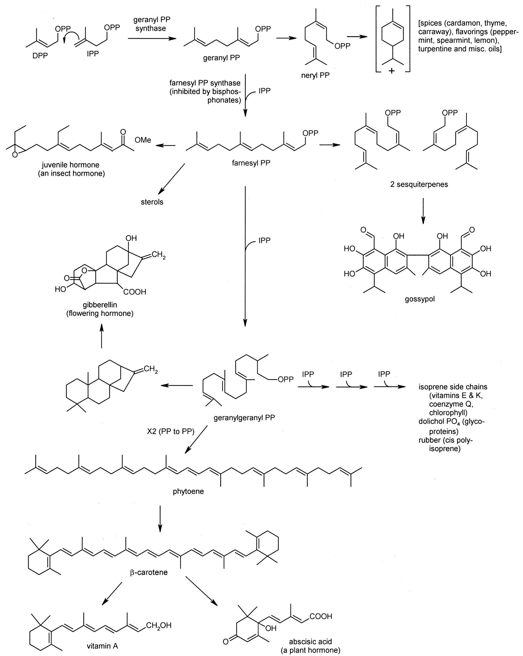

Fig. 4-12. A Representative Sampling of the Products of the Mevalonate Pathway.

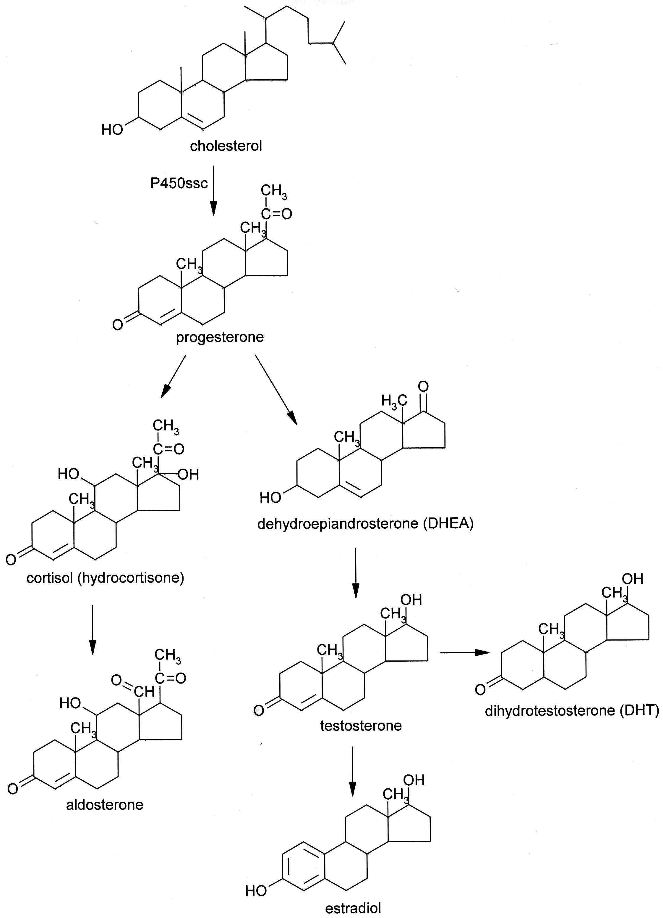
Fig. 4-13. An Abbreviated Scheme for Steroid Synthesis. In the adrenal gland, the major products are cortisol and aldosterone, while the gonads produce sex steroids exclusively.

b. Clinical Aspects: Lipids are hydrophobic and blood is hydrophilic; as such, lipids must be transported in particles surrounded by phospholipids and lipoproteins. The proteins determine the target cells by recognizing receptors on the cell surface. There are four basic lipid particles (Table 2). Chylomicrons are the largest and are produced by the intestinal epithelium. The particles are so large and viscous that they would clog capillaries. As such, they are secreted into lymphatic capillaries called lacteals because of their milky appearance. The lymph travels up the trunk and empties into the left subclavian vein, one of the largest veins in the body. This allows the chylomicrons to be rapidly diluted in the blood. This is the same strategy used by physicians needing to provide total parenteral nutrition to patients who cannot be fed by mouth. The concentration of nutrients is so high that it would sclerose peripheral veins. Rather, a central line is inserted in the subclavian vein so that the nutrients can be rapidly diluted. This technique is called hyperalimentation.

Table 2. Lipid Particles
Particle | Diameter  (nm) | Role | Composition (%)  TG CE/C PL Protein
Chylomicron | 75-1200 | Dietary fat transport | 86 | 4 | 8 | 2
VLDL | 30-80 | Endogenous fat transport | 52 | 21 | 18 | 8
LDL | 18-25 | Cholesterol transport | 10 | 46 | 22 | 21
HDL | 7.5-20 | Reverse cholesterol  transport | 5-10 | 17-28 | 19-29 | 33-57
Abbreviations: C, cholesterol; CE, cholesterol esters; HDL, high density lipoprotein; LDL, low density lipoprotein; PL, phospholipids; TG, triglycerides; VLDL, very low density lipoproteins.

Low density lipoprotein (LDL), also called “bad cholesterol” in the lay press, primarily carries cholesterol, which in high concentrations can build up in arteries. These cholesterol plaques can both stiffen and narrow arteries. High density lipoprotein (HDL), also called “good cholesterol”, helps to extract cholesterol from tissues.

Because of the dangers of high cholesterol levels, several treatments have been developed to lower cholesterol levels. To understand how cholesterol-binding resins work, the enterohepatic circulation needs to be described. Mother Nature is the original recycler: when cholesterol derivatives have served their purpose and need to be eliminated, they go to the liver where they are conjugated with hydrophilic groups. This modification makes them amphipathic; and all amphipathic molecules can act as detergents. These bile acids, as they are now called, are stored in the gallbladder and secreted into the intestines after a fatty meal to emulsify the fat and make them more susceptible to lipases. But the body isn’t done, yet: in the lower intestines, the bile acids are resorbed and transported back to the liver to be reused. Cholesterol-binding resins, like cholestyramine, bind bile acids in the gut and block resorption. This forces the liver to mobilize more cholesterol, thereby depleting endogenous stores.

The statins are competitive inhibitors of HMG CoA reductase and inhibit endogenous cholesterol synthesis. The latest addition to the pharmaceutical armamentarium against cholesterol are monoclonal antibodies to a serine protease, proprotein convertase subtilisin/kexin type 9 (PCSK9). To understand the mechanism of action of this drug, LDL metabolism needs to be described: LDL binds to a cell surface receptor, primarily on hepatocytes, and is internalized. Acidification of the phagosome induces the dissociation of the LDL proteins and cholesterol which are degraded. The LDL receptor may either recycle back to the plasma membrane to bind more LDL or it may bind PCSK9 which directs it to the lysosome to be destroyed. Monoclonal antibodies to PCSK9 bind and neutralize PCSK9. This allows the LDL receptor to be recycled, and more LDL can be internalized and degraded, thereby lowering cholesterol levels.

