Table of Contents

Section 1: Amino Acid Metabolism
1. Amino Acid Synthesis
a. Essential vs. Nonessential Amino Acids
b. Families
c. General Control Mechanisms
d. Glutamate Family
e. Serine and Aspartate Families
f. Pyruvate Family
g. Aromatic Amino Acid Family
h. Histidine
2. Amino Acid Catabolism
a. Introduction to Genetic Diseases
b. Urea Cycle
c. Aspartate and Pyruvate Families
d. Glutamate Family
e. Succinate Family
f. Acetoacetyl CoA Family
3. Amino Acid Derivatives

Section 2: Nucleotide Metabolism
1. Purine Synthesis
2. Pyrimidine Synthesis
3. Deoxynucleotide Synthesis
4. Nucleotide Catabolism

Unit 5: Amino Acid and Nucleotide Metabolism

Section 1: Amino Acid Metabolism
(Note: See any standard biochemistry textbook for a description of the enzymes and basic reactions. This section will concentrate on strategy using flow diagrams intermediate between elementary and advanced texts. They should provide more information than basic texts without distracting from the overall scheme. This section will also include regulation and a few special topics.)

1. Amino Acid Synthesis
a. Essential vs. Nonessential Amino Acids: Many biochemistry texts begin by listing the essential and nonessential amino acids, such as those presented in Table 1. Unfortunately, such a presentation is overly simplistic. First, the list is species-specific. Second, is an amino acid really nonessential if it is derived from an essential one? For example, the synthetic pathway for aromatic amino acids is quite complex and long; and humans do not possess any of the enzymes in this pathway. Yet, given phenylalanine humans can produce tyrosine via hydroxylation. As such, it seems somewhat of a stretch to call phenylalanine essential but call tyrosine nonessential. Third, the status of some amino acids is conditional; i.e., it is dependent upon the state of the animal. For example, arginine is listed as essential even though it is generated by the urea cycle (covered below). However, the arginine must be recycled to maintain the urea cycle. Nonetheless, in stable adults, enough arginine can be siphoned off for other functions; i.e., it is nonessential. However, the demand in young, growing animals is so great that supplemental arginine must be supplied in the diet; i.e., it is essential. Similarly, at high altitudes where oxygen availability is reduced, there is a heavy demand for cyteine to make the vasodilator, H₂S (see Succinate Family below). Under these conditions, cysteine becomes essential.

Table 1. Essential and Nonessential
Amino Acids
Nonessential | Essential
Alanine | Arginine
Asparagine | Histidine
Aspartic Acid | Isoleucine
Cysteine | Leucine
Glutamic Acid | Lysine
Glutamine | Methionine
Glycine | Threonine
Proline | Tryptophan
Serine | Valine
Tyrosine | Phenylalanine

Indeed, actual animal dietary experiments suggest that many “nonessential” amino acids are required in the diet secondary to ancillary uses: glutamic acid/glutamine is an excellent example. The two amino acids are readily interconvertible via amidation. Both glutamate and glutamine are used in protein synthesis; and together are the most abundant amino acids in proteins. Glutamate is used as an excitatory neurotransmitter and can be converted to GABA (γ-aminobutyric acid), an inhibitory neurotransmitter. Glutamate is a major nitrogen source for amino acids and glutamine, for nucleotides. Glutamate comprises one-third of glutathione, a major cellular antioxidant: glutathione concentrations are as high as 7 mM in hepatocytes. The TCA cycle is the source of many intermediates in anabolic pathways, such as amino acid synthesis. To keep the cycle functioning, these intermediates must be replaced in a process called anaplerosis; glutamate is a major player in this process. Finally, glutamate can be converted to αKG, a critical cosubstrate for αKG-dependent dioxygenases. Dioxygenases use molecular oxygen for oxidation reactions. However, molecular oxygen is diatomic (O₂), and the second oxygen atom has to go somewhere. In the αKG-dependent dioxygenases, αKG is the second substrate, which is oxidized to succinate. Two such enzyme families are the proline hydroxylases and the histone demethylases. The former simply hydroxylate proline. The latter remove methyl groups from the ε-amino groups of lysines by first hydroxylating the methyl group (Lys-CH₃ ─> Lys-CH₂OH), which is subsequently removed as formaldehyde.

There is one final consideration: no animal is sterile; the gut flora make significant contributions to the amino acid supply. Are these microbes considered part of the organism (nonessential) or is the animal considered in isolation, in spite of that being an entirely unnatural situation (essential)? As such, the division of amino acids into essential and nonessential groups is meaningless.

b. Families: All but one amino acid come from intermediates in either glycolysis or the TCA cycle (Fig. 5-1). The serine and pyruvate families come from 3-PG and pyruvate, respectively. The aromatic family begins with a condensation of PEP from glycolysis and erythrose-4-phosphate from the PPP. The aspartate and glutamate families come from the TCA cycle. Furthermore, glycolysis and the TCA cycle are linked via the sulfur-containing amino acids: the sulfur can be exchanged between cysteine (glycolysis) and methionine (TCA). Histidine is the odd-man-out; its synthesis begins with a condensation between phosphoribosyl pyrophosphate (PRPP) and ATP. Because of its unusual synthetic pathway, histidine is thought to have arrived late in evolution. Indeed, current theory has life beginning in an RNA world; proteins came later and not all amino acids were initially used. Although there is some dispute over the sequence, most model have the amino acid utilization occurring in three waves. The first amino acids to be incorporated into proteins were glycine, alanine, the acidic amino acids, the hydroxy amino acids, valine, leucine, and proline. The second wave included the basic amino acids, the amides, isoleucine and cysteine. The last wave consisted of the aromatic amino acids, methionine, and histidine. Histidine has odd precursors, the aromatic amino acids are expensive to make, and methionine is both expensive to synthesize and has three rotatable bonds, which would create a barrier to protein folding. It should be noted that all of this is highly speculative; for example, there are other models that postulate cysteine, histidine, and methionine as occurring earlier, because of their metal-binding properties.

Fig. 5-1. Amino Acid Families.

c. General Control Mechanisms: The core of regulation for amino acid synthesis is product inhibition. This can take one of four forms (Fig. 5-2). If the pathway is unbranched and the intermediates are needed in other pathways, the product inhibits the immediate preceding step. This halts further amino acid synthesis without interfering with the generation of intermediates for other uses. However, if the intermediates have no other function, then the product will feed back to the very first step. This will not only stop the synthesis of the amino acid but also that of intermediates that would otherwise just accumulate. Many pathways are branched, and products usually feed back to the branch point. This will inhibit further synthesis of the amino acid in excess without interfering with the synthesis of the other products. However, sometimes the products will inhibit the first step, which could impair the production of all the amino acids in this pathway. There are two solutions to this problem. In the first, there are multiple isozymes, each one regulated by one amino acid; i.e., the excess of one amino acid will inhibit only one isozyme, which decreases the total enzyme activity but does not totally block this step. Alternately, there may be one enzyme with multiple allosteric sites, one for each product. The occupancy of any single site partially inhibits the enzyme. The effect of these sites is additive; i.e., the more sites occupied, the greater the inhibition.

Fig. 5-2. Feedback Inhibition in Amino Acid Synthesis. A represents the initial substrate and Y and Z the final products. The dotted lines with flat arrowheads represent feedback inhibition.

d. Glutamate Family
1) Strategy: The glutamate family has a relatively simple synthetic scheme (Fig. 5-3); αKG from the TCA cycle is transaminated to form glutamate; and glutamate can be amidated to form glutamine. Alternatively, the γ-carboxy group can be reduced to an aldehyde. This occurs via a phosphorylated intermediate, which explains the enzyme’s name: glutamate kinase/reductase (also called pyrroline-5-carboxylate synthase). The aldehyde and amino groups form an intramolecular Schiff base, which is then reduced to form proline.

Fig. 5-3. An Abbreviated Synthetic Pathway of the Glutamate Family.

The synthesis of the last member of this family, arginine, is more complex; it involves the construction of a guanidino group on the end of the side-chain. First, the γ-carboxy group is reduced to an aldehyde. As noted above, this could lead to an intramolecular Schiff base. To prevent this, the amino group is blocked by acetylation. The aldehyde remains free for transamination, after which the amino group can be safely deacetylated. Next, a carbamoyl group is attached to the γ-amino group. The only thing left is to transaminate the ketone to create the guanidino group. Unfortunately, the last steps are actually more complicated than a simple transfer of an amino group. The amino group will come from aspartate, but the transfer is not clean. The aspartate will not let go, producing a hybrid molecule: argininosuccinate. Finally, the aspartate is removed as fumarate and the amino group remains with the arginine.

2) Regulation: This is a branched pathway and the products will feed back to the branch points (Fig. 5-4). However, every pathway is unique and there are also some specialized modifications to this regulatory scheme. The right side of Fig. 5-4 is simple in animals: proline feeds back to inhibit its branch point, the glutamate kinase/reductase. The plant enzyme is unresponsive to proline, which allows proline levels to reach 100 mM during stress. During osmotic stress, proline acts as an osmolyte. An osmolyte is a small molecule that stabilizes macromolecules in high-osmolarity environments. During oxidative stress, it acts as a protectant and chemical chaperone. Indeed, this enzyme is induced by abscisic acid, a plant stress hormone. In animals there are two isozymes of the glutamate kinase/reductase. The short form is found in the gut and is inhibited by ornithine; the long form is ubiquitous and its activity is not affected by ornithine. In the gut, the major function of this pathway is to synthesize arginine; and this cross-talk between branches shunts glutamate from proline to arginine. The long form is inhibited by glucocorticoids and induced by estrogens. Glucocorticoids were introduced in this supplement as a stress hormone stimulating energy mobilization: gluconeogenesis, lipolysis, etc. However, it is also anti-inflammatory; and its actions on the glutamate kinase/reductase may be to limit the inflammatory response by reducing collagen synthesis. Collagen is a major constituent of scar tissue and about 25% of its amino acid composition is proline. Restriction of proline synthesis would impair collagen synthesis. Indeed, glucocorticoids are used clinically to reduce scar tissue formation. On the other hand, estrogen has a pronounced proliferative effect on reproductive tissues and collagen is a major component of connective tissue. Therefore, it is logical that estrogens would induce this enzyme. The left side of Fig. 5-4 is complicated by the fact that ornithine has other functions (see below); therefore, arginine does not completely shut down the N-acetylglutamate synthase. Instead, it additionally inhibits the ornithine transcarbamoylase, the first step beyond ornithine. Another problem is carbamoyl phosphate. First, it is metabolically expensive to make: one ATP to synthesize carbamate and a second ATP to activate it via phosphorylation. Second, it is highly unstable. To insure that it is not wasted, carbamoyl phosphate synthetase has an obligatory requirement for N-acetylglutamate. Essentially, this tells the enzyme that there will be adequate ornithine to accept the carbamate.

Fig. 5-4. Regulation of the Glutamate Family. Red dotted lines with flat heads represent inhibition; the green dotted line with an arrowhead represents an obligatory activator.

3) Interrelations Among the Branches: The branches in most amino acid synthetic pathways are functional unrelated; they share the pathway simply because of a structural similarity. However, there is an interesting functional connection among the branches of the glutamate family (Fig. 5-5). Ornithine can have three fates: it can be converted to arginine as described above; it can be decarboxylated to form putrescine, the first in a series of polyamines; or it can lose its γ-amino group by transamination. In the latter case, the recreation of an aldehyde in the absence of a blocked α-amino group leads to the formation of a Schiff base and, after reduction of the double bond, proline. Arginine can also have three fates: it can be siphoned off for protein synthesis; in the urea cycle, urea is split off the guanidino group to eliminate waste nitrogen and the ornithine is recycled; and in the citrulline-NO cycle, NO is split off the guanidino group and the citrulline is recycled.

Fig. 5-5. The Interrelationships Among the Glutamate Family Members. Abbreviations: NO, nitric oxide; NOS, nitric oxide synthetase; ODC, ornithine decarboxylase; Orn, ornithine.

In response to injury or infection, NOS is induced to synthesize NO, which is both a stress hormone and antimicrobial. Once the field is sterilized, the substrate flow is shifted to polyamines and proline for the regenerative phase. Polyamines are molecules with multiple amino groups; they bind to nucleic acids and are essential for transcription and translation, both of which are required for tissue repair. In addition, proline is needed for the synthesis of collagen, a major component of scar tissue.

e. Serine and Aspartate Families
1) Strategy: As the serine and aspartate families are linked by the exchange of sulfur, they will be considered together (Fig. 5-6). The aspartate family mirrors the glutamate family. OAA from the TCA cycle is transaminated to make aspartate and transamidated to make asparagine. Alternatively, the β-carboxy group can be progressively reduced to an aldehyde and then a hydroxyl group. Unlike with glutamate, the amino group does not have to be blocked to prevent an intramolecular Schiff base because the aspartate has one less carbon and the ring would only contain four atoms. Such a ring is too strained to form spontaneously. Finally, the hydroxyl group is moved to the adjacent carbon to make threonine. To make lysine, the R group must be extended and an amino group added. The former is accomplished by reducing the β-carboxy group to an aldehyde and coupling it to a pyruvate. The longer chain combined with the ketone results in an intramolecular Schiff base that transiently creates a six membered ring (not shown). This is broken by succinylating the amino group; the free ketone can now be transaminated. The synthesis is complete after deblocking the amino group and decarboxylating the R group.

Fig. 5-6. An Abbreviated Synthetic Pathway of the Serine and Aspartate Families.

Some microorganisms use an alternate pathway to synthesize lysine. It is presented to illustrate two points. First, any difference in a metabolic pathway between microorganisms and animals may be targeted by antimicrobial drugs. Second, this particular pathway shows how slight changes in enzyme specificity can create new molecules. Basically, it is the TCA cycle where αKG replaces OAA. αKG (≈OAA) is coupled to acetyl CoA to make homocitrate (≈citrate); the hydroxy group is shifted to the adjacent carbon to form isohomocitrate (≈isocitrate), and then oxidized to form α-ketoadipate (≈α-ketoglutarate). The last steps involve transamination of the ketone, reduction of the ε-carboxyl group and its transamination.

Fig. 5-7. The α-Aminoadipate Pathway for Lysine Synthesis. Negative feedback is indicated by the red dotted line with a flat arrowhead.

The synthesis of serine involves three simple steps (Fig. 5-6): 3-PG from glycolysis undergoes oxidation on the hydroxy group followed by transamination; then the phosphate is removed. These three enzymes form a metabolon. Glycine is formed by the further removal of a hydroxymethyl group. Methionine can donate its methyl group to many substrates via SAM; the resulting homocysteine can be used to regenerate methionine or to synthesize cysteine. In the latter case, homocysteine is coupled to serine in a tail-to-tail fashion to form cystathionine. The cystathione is then split on the other side of the sulfur so that it remains with the serine to become cysteine. The homocysteine is ripped apart in the process to form αKG and ammonia. Alternatively, cysteine can be used to synthesize methionine. In this case, cysteine is coupled tail-to-tail to homoserine, an intermediate in threonine synthesis. Now the cystathionine is cleaved so as to leave the sulfur with the homoserine to form homocysteine and it is the cysteine that is torn apart to form pyruvate and ammonia. The addition of a methyl group to the tail of homocysteine by methionine synthase completes the synthesis of methionine.

2) Regulation: The regulation of these families is shown in Fig. 5-8. The aspartate family is a branched pathway and uses a combination of the isozyme and the branch point solutions (Fig. 5-2). First, there are three isozymes of the first enzyme, aspartokinase: aspartokinase I is allosterically inhibited by threonine; aspartokinase II, by methionine; and aspartokinase III, by lysine and isoleucine. Isoleucine is synthesized from threonine; because the steps are identical to part of the pyruvate family, it will be considered in parallel with the pyruvate family later. Second, these amino acids also feed back to inhibit
the branch point, or immediately preceding step in the case of a linear sequence.

Serine is a linear pathway that feeds back to the immediately preceding step, the phosphoserine phosphatase. In addition, serine is an activator of pyruvate kinase. Serine deficiency decreases pyruvate kinase activity and glycolysis backs up. As a result, 3PG accumulates and can be diverted to serine synthesis. Once serine levels have been restored, pyruvate kinase is reactivated and glycolysis resumes. The enzymes can also be regulated by gene induction: transforming growth factor β (TGFβ) stimulates collagen synthesis. About one-third of the amino acids in collagen are glycine; and TGFβ induces all of the enzymes for serine synthesis (phosphoglycerate dehydrogenase, phosphoserine aminotransferase I, and phosphoserine phosphatase) and the enzyme that convert serine to glycine (serine hydroxymethyltransferase 2).

Serine is a single-carbon source that is essential for growth; and serine biosynthesis is stimulated in both normal and abnormal growth, such as cancers. This stimulation is effected by protein arginine methyltransferase 1 (PRMT1), which methylates 6-phosphofructose-2-kinase/fructose-2,6-bisphosphatase (PFKFB), PGA dehydrogenase, and pyruvate kinase. The first two enzymes are stimulated and the latter is inhibited. PFKFB produces F-2,6-P, an allosteric activator of phosphofructokinase, the committed step in glycolysis; but methylation inhibits pyruvate kinase, the final step in glycolysis (see Unit 3). This results in the accumulation of glycolytic intermediates, like 3PG. PGA dehydrogenase converts 3PG to phosphohydroxypyruvate, the first and committed step toward serine synthesis. In summary, methylation by PRMT1 stimulates glycolysis but blocks the final step so that intermediates can be shunted into serine synthesis.

Finally, in plants the PGA dehydrogenase, is activated by reducing conditions, which break an inhibitory disulfide bridge within the enzyme. Reducing conditions occur during active photosynthesis and signify abundant energy for growth. Serine is an important requirement for growth not only as an amino acid but also as a single carbon donor.

f. Pyruvate Family
1) Strategy: The pyruvate family begins with a simple transamination of pyruvate to give alanine (Fig. 5-9). Another branch decarboxylates pyruvate by the same mechanism as the pyruvate dehydrogenase that bridges glycolysis and the TCA cycle. However, instead of TPP transferring the acetyl group to lipoic acid, it is transferred to either another pyruvate to eventually make valine or to threonine to eventually make isoleucine. The reactions in both pathways are the same and in some species are performed by the very same enzymes. In those species where the enzymes are distinct, they are nonetheless homologous. After conjugation, the R group is moved to the adjacent carbon and water is removed to recreate the α-keto group which is transaminated. If the R group is a methyl group (i.e., it came from pyruvate), the amino acid formed is valine. If the R group is an ethyl group (i.e., it originated from threonine), the amino acid synthesized is isoleucine.

Fig. 5-8. Negative Feedback Regulation of Amino Acid Synthesis. The numbered enzymes are as follows:
1, aspartokinase; 2, homoserine dehydrogenase; 3, homoserine kinase; 4, threonine deaminase; 5, dihydrodipicolinate synthase; 6, acetolactate synthase; 7, α-isopropylmalate synthase; 8, homoserine acyltransferase; 9, phosphoserine phosphatase; 10, cystathionine β synthase; 11, cystathionine γ lyase; 12, anthranilate synthase; 13, chorismate mutase P/perphenate dehydratase; 14, chorismate mutase T/perphenate dehydrogenase; 15, 2-keto-3-deoxy-D-arabino-heptulosonate 7-phosphate synthase.

Fig. 5-9. An Abbreviated Synthetic Pathway of the Pyruvate Family.

To synthesize leucine, an acetyl group is added to the α-keto group of the isoleucine precursor before transamination. The resulting hydroxy group is removed as water to create a double bond and then added back to the adjacent carbon (cf. aconitase reaction in the TCA cycle). After decarboxylation of the central carboxylic acid, the hydroxy group is oxidized and transaminated.

b) Regulation: Valine feeds back to inhibit the first step and leucine inhibits the enzyme at the branch point (Fig. 5-8). Isoleucine is technically part of the aspartate family and feeds back to inhibit aspartokinase III. However, it also inhibits the threonine deaminase, the first step beyond threonine. Furthermore, there is crosstalk between the two families: both valine and isoleucine inhibit the "first" step in the other's pathway. This crosstalk helps to maintain a proper balance among amino acid concentrations.

g. Aromatic Amino Acid Family
a) Strategy: The synthesis of the aromatic amino acids begins with the ring. The most common pathway in animals forms the phenyl ring from aspartate and PEP (top of Fig. 5-10); bacteria and plants use 6-deoxy-5-keto-fructose-1-phosphate and aspartate semialdehyde (the shikimate pathway; left side of Fig. 5-10). If tyrosine or phenylalanine is to be synthesized, a second PEP is added to form chorismic acid and then shifted to a nearby carbon to form prephenate. For tyrosine, the ring is decarboxylated, aromatized and the 2-keto group is transaminated. For phenylalanine, the hydroxy group is removed, which leads to aromatization of the ring; and the 2-keto group is then transaminated. Animals can readd the hydroxyl group to phenylalanine to synthesize tyrosine.

The second PEP is not needed in tryptophan synthesis; so it is removed and the ring is transaminated to form anthranilate. The side ring is formed from the amino group and two carbons from PRPP. In the last step, the unused portion of the PRPP is lost as glyceraldehyde-3-phosphate, and the indole ring is transferred to serine. This step is catalyzed by tryptophan synthase, a tetramer (α₂β₂). The α subunit splits off the glyceraldehyde-3-phosphate, and the β subunit couples the indole ring to serine. Between the two is a hydrophobic tunnel. The enzyme actually has a higher affinity for threonine than serine, but threonine binding disrupts the indole binding, thereby insuring that the indole ring will only be attached to serine.

b) Regulation: The regulation of the aromatic amino acid family is highly variable. It is a branched pathway and one common mechanism is a combination of branch point and first step regulation: each of the amino acids feeds back to inhibit its branch point (Fig. 5-8). This results in the accumulation of chorismic acid and perphenate, which then feed back to inhibit the first step, the 2-keto-3-deoxy-D-arabino-heptulosonate 7-phosphate synthase (DAH7PS). However, in other bacterial species, the amino acids themselves can directly inhibit DAH7PS (Fig. 5-11). Depending on the species, the DAH7PS may either be a single enzyme with separate allosteric sites for tyrosine, phenylalanine, and tryptophan or consist of separate isozymes, each inhibited by a different amino acid. In plants, tyrosine and phenylalanine feed back to inhibit the chorismate mutase, while tryptophan stimulates it. This mechanism helps to insure the proper balance among amino acid concentrations. In the bacterium Prevotella
nigrescens, DAH7PS and chorismate mutase form a complex: DAH7PS substrates allosterically activate chorismate mutase (feed forward), while substrates for the latter enzyme allosterically inhibit DAH7PS (negative feedback). During starvation, bacteria produce the alarmone, (p)ppGpp (guanosine pentaphosphate), which inhibits purine synthesis by binding and inhibiting inosine-guanosine kinase, an enzyme in the purine salvage pathway. This action conserves PRPP for use in tryptophan and histidine (see below) synthesis. In plants, DAH7PS requires a reducing environment; this insures that aromatic amino acid synthesis only occurs during active photosynthesis, which provides the necessary materials and energy. Animals cannot make aromatic acids de novo, but they can convert phenylalanine to tyrosine via phenylalanine hydroxylase. This enzyme is stimulated by phenylalanine (substrate driven). In mammals the enzyme can also be stimulated by PKA phosphorylation. PKA mediates the signaling of several stress hormones; and the tyrosine thus formed can be used to synthesize catecholamines (i.e., epinephrine and norepinephrine) to enhance the stress response.

h. Histidine: It is believed that histidine was added late in evolution because of its unusual synthetic pathway. The body of the amino acid comes from ribose (PRPP), while the ring is composed of atoms from ribose, the purine ring of ATP and ammonia (Fig. 5-12). Briefly, the C1’ of ribose is activated by the pyrophosphate which is displaced by the N1 of the purine ring. This is the first and regulated step; it is inhibited by an excess of histidine. After loss of the β and γ phosphates from ATP, the purine ring is split between N1 and C6 and the hemiacetal ring of ribose is cleaved. A second purine cleavage between C2 and N3 leaves the N1 and C2 atoms with the ribose. These atoms, along with ammonia, will cyclize to form the imidazole ring of histidine. A dehydration reaction will remove the hydroxyl group from the third carbon and convert the second carbon to a ketone which is transaminated. All that is left is to dephosphorylate the first carbon and oxidize it to a carboxylic acid.

Fig. 5-10. An Abbreviated Synthetic Pathway of the Aromatic Amino Acid Family. Step (1) associated with chorismic acid directs the substrate into the Tyr/Phe pathway, while step (1') leads to the synthesis of Trp.

Fig. 5-11. Regulatory Variations in the Aromatic Amino Acid Family. Variations in plants (dotted lines), animals, (solid lines) and bacteria (dashed lines). Dotted/dashed lines depict overlapping regulation by plants and bacteria. The numbered enzymes are as follows: 13, chorismate; and 15, 2-keto-3-deoxy-D-arabino-heptulosonate 7-phosphate synthase (DAH7PS). Depending on the species, the DAH7PS may either be a single enzyme with separate allosteric sites for tyrosine, phenylalanine, and tryptophan or consist of separate isozymes, each inhibited by a different amino acid.

2. Amino Acid Catabolism
a. Introduction to Genetic Diseases: Heretofore, no mention has been made of genetic diseases. The reason resides in the fact that humans eat far more protein than is necessary, and any deficit in endogenous synthesis will be masked by the glut of exogenous amino acids. There are, of course, exceptions: some amino acids are required at very high concentrations and/or in very discreet domains, such as synapses where they must be synthesized in situ. For example, proline comprises 25% of the amino acids in collagen, the most abundant protein in the body. A deficiency of glutamate kinase/reductase (also called pyrroline-5-carboxylate synthetase) will produce joint laxity and skin hyperelasticity. However, deficits in amino acid catabolism are much more clinically significant than those of amino acid synthesis.

Fig.5-12. An Abbreviated Synthetic Pathway for Histidine.
The numbers indicate the order of the reactions.

The first question to address is “why is there a problem with deficits in amino acid catabolism?” Such a deficit would simply result in the accumulation of the affected amino acid. Most students consider amino acids to be relatively benign compounds and eventually they would be excreted anyway. First of all, some amino acids are active. For example, glycine is used as an inhibitory neurotransmitter. A defect in the glycine cleavage complex results in the accumulation of glycine and excessive neural inhibition leading to hypotonia, lethargy, and apnea attacks. Second, it may not be the amino acid itself, but a toxic intermediate that accumulates. In tyrosinemia I, a defective fumarylacetoacetate hydrolase (also called fumarylacetoacetase) leads to the accumulation of fumarylacetoacetate, which is subsequently reduced to succinylacetoacetate and then decarboxylated to succinylacetone, a highly hepatotoxic and nephrotoxic compound. Sometimes it isn’t the biological activity, but the physical properties that prove damaging. Excess cysteine will dimerize to form cystine and precipitate to form kidney stones. It can also form disulfide bonds with any free cysteines in proteins, potentially disrupting the function of that protein.

One of the more interesting effects of these diseases arises from the deficiency of useful products downstream. Many catabolic pathways are not simple conduits to the dumpster; Mother Nature is the original recycler. For example, cysteine breakdown products are precursors for taurine (H₂NCH₂CH₂SO₃H), a compound that can be conjugated to bile salts to make them more soluble, or act as an antioxidant, membrane stabilizer or osmolyte (see proline above for a discussion of osmolytes). Its absence can lead to male infertility secondary to the inability of sperm to adjust to the change in osmolarity as they move from the caudal epididymus (420 mosm) to the uterus (320 mosm). Another example is kynurenine, a breakdown product of tryptophan and a natural immunosuppressant. The immune system can be very toxic and there are countermeasures, such as kynurenine, to maintain a balance between effectiveness and toxicity. An absence of kynurenine leads to hyperimmunity.

The treatment of genetic diseases is very challenging. The holy grail, of course, is gene therapy; and with Crisper technology, this possibility is closer than ever. Until then, there are other ways to replace or repair the affected enzyme. One can simply inject it. Unfortunately, injected protein has a very short half-life and may generate an immune response. These adverse effects may be ameliorated by covalently modifying the enzyme by PEGylation (a synthetic polymer) or lipidization with either myristic or palmitic acid. Alternatively, it can be encapsulated by or attached to erythrocytes or genetically engineered to form self-assembled, nanocage icosahedrons. Since the urea cycle is located in the liver, a lobulated organ, liver transplantation of a lobe from a histocompatible donor is possible. Another strategy is based on the fact that the majority of mutations do not directly affect the active site of a protein; rather they lead to misfolding. There are several chemical chaperones that have been used to induce mutant proteins to fold correctly. Alternatively, drugs known to induce endogenous chaperones, the heat shock proteins, can be administered. If the affected enzyme has residual activity and uses a coenzyme, vitamin supplements can be used to drive the low-activity mutants. Another way to augment residual activity is the use of lncRNA (long, noncoding RNA). These RNAs have multipled functions: one, HULC (highly upregulated lncRNAs in liver cancer), facilitates the interaction of phenylalanine hydrolyase with its substrate and cofactor. Finally, it may be possible to chemically correct certain selected mutants. Argininosuccinate lyase is the second most commonly mutated enzyme in the urea cycle. Arginine-to-cysteine mutants can be treated with cysteamine (HSCH₂CH₂NH₂). The cysteamine forms a disulfide bond with the cysteine, giving it a positively charged side-chain that mimicks the original basic amino acid and restores activity.

Amino acid restictions represent another approach. Limiting protein intake is central to most treatments, but it must balanced against the needs of the individual during active growth or illness. Endogenous protein breakdown can be reduced by increasing caloric intake and avoiding fasting. If the patient is female, the menses can be suppressed with depo progesterone. Alternatively, intestinal absorption can be blocked: e.g., phenylalanine in phenylketonuria. Phenylalanine must be converted to tyrosine before it can be degraded. A deficiency of phenylalanine hydroxylase will lead to phenylketonuria. Phenylalanine, like all amino acids, is a zwitterion and cannot cross plasma membranes without a transporter. Large, neutral amino acids all compete for the same transporter in the gut; and when these other amino acids are administered in large amounts, they can reduce phenylalanine absorption. A similar trick can be used with the blood-brain barrier. For example, in glutaric acidemia I the body cannot completely breakdown lysine and the intermediate, glutaric acid, accumulates; this compound is very toxic to the nervous system. Homoarginine uses the same transporter as lysine and can block the uptake of lysine by the nervous system. Molecularly imprinted polymers are another way to impede absorption. Such polymers are designed to contain binding sites for specific ligands, such as phenylalanine, which are then sequestered in the gut. Finally, the amino acid can be destroyed in the gut before it can be absorbed. Pegylated phenylalanine ammonia lyase can be administered orally; it converts dietary phenylalanine to harmless trans-cinnamic acid. Currently, an acid stable methionine γ lyase is being studied as a way to lower methionine in the gut in homocystinuria.

The last group of treatments involves ameliorating the toxic effects of these metabolites, such as the administration of antioxidants in homocystinuria in order to block spurious disulfide bond formation with the excess homocysteine. It may also be possible to prevent the formation of the toxic intermediate by pharmacologically blocking an earlier step, resulting in the build up of a less toxic intermediate. Tyrosinemia I and its toxic product, fumarylacetoacetate, have already been mentioned above. One treatment for this disease is dichloroacetate, an inhibitor of maleylacetoacetate isomerase, which catalyzes the synthesis of fumarylacetoacetate. Alternatively, nitisinone [2-(2-nitro-4-trifluoromethylbenzoyl)-1,3 cyclohexanedione or NTBC), can be used to inhibit 4-hydroxyphenylpyruvate dioxygenase, an enzyme even further upstream in this pathway.

Finally, one may be able to restore levels of a critical molecule that is deficient due to the metabolic defect. In propionic acidemia, propionyl CoA accumulates because of a defect in propionyl-CoA carboxylase; this results in the sequestration of coenzyme A in propionyl CoA. BBP-671 activates pantothenate kinase by allosterically blocking coenzyme A feedback inhibition. This restores coenzyme A levels.

b. Urea Cycle: Amino acids are degraded into ammonia and carbon skeletons. The ammonia is detoxified in the urea cycle and the fate of the carbon skeletons depends on their size: glucogenic amino acids have at least three carbons and can be fed into gluconeogenesis. Ketogenic amino acids have only two carbons or are long chains that are broken down like fatty acids into acetyl CoA. They are transported as ketone bodies to peripheral tissues where they are degraded in the TCA cycle. Most standard textbooks show amino acids being fed into the TCA cycle at various nodes. However, this is controversial. Some authorities claim that the components of TCA cycle are more like catalysts than substrates; i.e., they ferry acetyl CoA thru the cycle. Substrates can only enter through the front door after being converted to pyruvate. However, components of the TCA cycle are constantly being siphoned off for various anabolic pathways and must be replenished in a process called anapleurosis. As such there is precedence for molecules entering the TCA cycle through side-doors.

Nitrogen is removed from amino acids through either transamination or glutamate dehydrogenase (Fig. 5-13). The latter enzyme is activated by starvation (by ADP or by NAD⁺ via SIRT/deacetylation), when amino acids would be catabolized for gluconeogenesis, or an excess of amino acids that need to be cleared (leucine is sampled as a representative because it is the most abundant amino acid in proteins). It is inhibited by high energy (e.g., by GTP, ATP, or acetylation) and palmitoyl CoA, which may represent active fatty acid synthesis; i.e., an anabolic state.

Fig. 5-13. The Urea Cycle and Its Regulation. The mitochondrion is in gray; the nitrogens from aspartate (bold) and ammonia (italics) are denoted by different fonts. Additional regulation of the argininosuccinate synthetase is described in the text.

Briefly, the ammonia generated by glutamate dehydrogenase is used to make carbamoyl phosphate, which is then attached to ornithine to make citrulline (see also arginine synthesis in Fig. 5-4). Meanwhile, other amino acids are transferring their amino groups to OAA to form aspartate. Argininosuccinate synthetase (ASS) joins citrulline and aspartate and is the rate-limiting step in the urea cycle. Its regulation depends upon the tissue in which it is located. In the liver, it is part of the urea cycle and is sensitive to amino acid metabolism. For example, cortisol and glucagon stimulate gluconeogenesis, which generates ammonia; as such, they induce this enzyme. Glutamine is a storage form of nitrogen and elevated glutamine levels signify an excess of nitrogen that needs to be eliminated. Again, glutamine induces the enzyme. On the other hand, insulin is anabolic; it needs amino acids for growth. Insulin blocks the effects of cortisol on argininosuccinate synthetase induction in the liver.

In the small intestines (in the fetus and neonate), kidney (in the child and adult), and placenta, ASS is used to synthesize arginine. Its expression in the first two tissues is preprogrammed, while cAMP induces it in the third.

In immune cells and endothelium, ASS is part of the citrulline-NO cycle. Nitric oxide is used as a defensive weapon and signaling molecule in inflammation in the former and as a vasodilator in the latter. In the former, it is induced by cytokines and other inflammatory hormones. It can also be stimulated by phosphorylation by PKA and PKC. The former is elevated by stress hormones.

Bradykinin is a peptide vasodilator that induces hypotension; it is degraded by the peptidase, angiotensin. Bradykinin-potentiating peptide blocks the production of angiotensin and, therefore, prolongs the half-life of bradykinin. It further potentiates the effect of bradykinin by binding ASS and stimulating it to make NO. In addition, insulin, which inhibits the induction of ASS in the liver, stimulates it in the endothelium.

Finally, ASS is inhibited by acetylation. Acetylation usually signifies abundant energy; i.e., there is no need for gluconeogenesis or ammonia detoxification. Therefore, the acetylation of several enzymes in the urea cycle are inhibited by this modification. These include carbamoyl phosphate synthetase, ornithine transcarbamoylase, ASS, and argininosuccinase (also called argininosuccinate lyase). However, the acetylation of ASS has additional meaning. This enzyme is acetylated by CLOCK, a circadian regulator and acetyltransferase. As a result, in rodents acetylation (and enzyme inhibition) is greatest during the day, while ASS activity is highest at night.

To finish the cycle, the argininosuccinate is split into arginine and fumarate. The fumarate is recycled to OAA via the same reactions that occur in the TCA cycle. The arginine is split into urea, which is excreted, and ornithine, which can accept another carbamoyl phosphate.

c. Aspartate and Pyruvate Families: The degradation of the aspartate family is simple (Fig. 5-14). Aspartic acid undergoes transamination to form OAA; the amide on asparagine is hydrolyzed first before transamination.

Fig. 5-14. An Abbreviated Scheme for Degradation of the Aspartate Family. The numbers indicate the order of the reactions.

The pyruvate family is also relatively simple (Fig. 5-15): alanine undergoes transamination to form pyruvate, while the nitrogen in serine is removed by dehydration. The latter reaction is reversible but not stereospecific, leading to the generation of D-serine, a neurotransmitter. As such, the enzyme produces both pyruvate and D-serine in a 3:1 ratio and links the production of D-serine with starvation: e.g., D-serine inhibits insulin secretion.

Fig. 5-15. An Abbreviated Scheme for Degradation of the Pyruvate Family.

Glycine is degraded in pairs. The glycine cleavage system (also known as the glycine decarboxylation complex) will dismember one glycine into CO₂, NH₃, H⁺, and single carbon units attached to tetrahydrofolate (THF):

Glycine + THF + NAD⁺ 5,10-methylene-THF + CO₂ + NH₃ + NADH + H⁺

This reaction is the major source of single carbons for THF and SAM; and it represents the limiting factor during rapid growth (e.g., embryogenesis and cancer growth). However, if the carbons are not needed, they are transferred to a second glycine by the serine hydroxymethyl transferase, which is the rate limiting step in glycine degradation. It is inhibited by succinylation on a lysine and reactivated when SIRT5 removes the succinyl group. In this way, amino acid breakdown is linked to starvation: starvation elevates NAD⁺ which stimulates SIRT to remove succinate. Threonine can have several fates. In Fig. 5-15, it is degraded like a fatty acid: the hydroxy group is already present; so it only needs to be oxidized and cleaved into glycine and acetyl CoA. Threonine can also be used to synthesize isoleucine (see above).

Cysteine is the last member of this family. First, the sulfur is oxidized by the cysteine dioxygenase to cysteine sulfinic acid. This intermediate can either be converted to taurine (an osmolyte discussed above) or continue being degraded by removing the nitrogen by transamination followed by the sulfur by desulfuration (i.e., the sulfur is released as SO₂). There are several interesting aspects of the cysteine dioxygenase. First, it has an unusual intramolecular cross-link: a thioether between the sulfur of cysteine 93 and the meta-position of tyrosine 157. This bond increases enzymatic activity 10-fold. Second, it uses free cysteine as a coenzyme; essentially the enzyme is substrate driven. If cysteine is in excess, there is sufficient amino acid to activate the dioxygenase; but if cysteine levels are low, the amino acid is conserved because there is inadequate coenzyme for the dioxygenase. Finally, the dioxygenase binds to PPARγ and acts as a transcriptional coactivator during adipogenesis. Taurine is known to have an important role in adipose tissue and this relationship may be a way PPARγ knows that taurine levels are adequate. On the other hand, this may represent feed forward regulation, since PPARγ can induce the gene for cysteine dioxygenase.

Alternatively, the sulfur in cysteine can be recycled. There are several enzymes that can remove the sulfur to produce alanine, which can then undergo transamination to pyruvate (not shown in Fig. 5-15). The molybdenum cofactor sulferase uses the sulfur to sulfrate xanthine dehydrogenase and aldehyde oxidase; both enzymes use one oxygen and one sulfur to ligate the metal ion. The desulfurase also associates with the cytochrome bc1 complex and cytochrome c oxidase to provide sulfur for Fe-S clusters. In plants, cysteine desulfhydrase is the only known source of hydrogen sulfide, a signaling molecule (see also methionine catabolism below).

d. Glutamate Family: Glutamic acid and glutamine are treated like aspartic acid and asparagine above: after removal of the nitrogens, the αKG is fed into the TCA cycle (Fig. 5-16). Proline degradation is simply the reverse of synthesis: a double bond is reinserted into the ring to recreate the Schiff base (proline dehydrogenase); after ring cleavage the semialdehyde is oxidized to glutamate (glutamate-5-semialdehyde dehydrogenase). In bacteria, these two enzymes are fused, while in other organisms they display substrate channeling. Arginine is converted to ornithine via arginase of the urea cycle (Fig. 5-13), and transamination of the ornithine yields glutamate semialdehyde, which is oxidized as above.

Fig. 5-16. An Abbreviated Scheme for the Degradation of the Glutamate Family.

The odd man out is histidine whose synthesis was unconnected to the glutamate family but whose degradation is. First, the amino group is removed by the histidine ammonia lyase (also called histidase) to create the R group for glutamic acid; essentially the “head” of histidine will become the “tail” of glutamic acid. Water is added across the double bond at the 4/5 position of the imidazole ring and the hydroxyl group is oxidized. Ring cleavage between C5 and the τ nitrogen is followed by the removal the τ nitrogen and adjacent C2 as a formimino group. The result is glutamic acid where C4 is the new α carboxy group and the π nitrogen is the new α amino group.

The product of the first step in histidine degradation, urocanic acid, is elevated after ultraviolet (UV) light exposure. The mechanism is unknown; it does not appear to induce the histidase. UV light can isomerize urocanic acid between the cis and trans isomers; this absorbs energy and enables urocanic acid to act as a sunscreen. In addition, urocanic acid can cross the blood-brain barrier and be used by neurons to make glutamic acid, an excitatory neurotransmitter in the central nervous system (CNS). Indeed, UV light has been shown to elevate glutamate in the CNS and this is thought to be the basis for UV-induced mood elevation and improved cognition.

e. Succinate Family: The three amino acids in this family are broken down into propionyl CoA (Fig. 5-17). The reader will recall that this is the same molecule produced by the breakdown of fatty acids having an odd number of carbons; and it is handled in exactly the same way: it is converted to succinyl CoA and fed into the TCA cycle. Valine and isoleucine are degraded in the same manner: transamination generates an α-ketoacid, which, after an oxidative decarboxylation, becomes the new carboxy terminus coupled to coenzyme A. The transaminase and decarboxylase are part of a metabolon and the resulting substrate channeling increases efficiency. The rest of the pathway resembles fatty acid oxidation: an α-β double bond is introduced, hydrated, and the hydroxyl group oxidized to a carbonyl. For isoleucine, subsequent cleavage yields an acetyl CoA and a propionyl CoA. Valine has one less carbon, which leaves a lone aldehyde at the end; it is removed by decarboxylation to yield only the propionyl CoA. Regulation occurs at the branched chain α-keto acid dehydrogenase (BCKD), which catalyzes the oxidative decarboxylation step. BCKD is inhibited by the BCKD kinase (BCKDK). BCKDK is induced by insulin; the result is the suppression of valine and isoleucine catabolism so that insulin can use them in anabolic pathways. Furthermore, growth factors can trigger the tyrosine phosphorylation of BCKDK. This stimulates and stabilizes the kinase; again this diverts valine and isoleucine from catabolism to anabolism. On the other hand, BCKDK is inhibited by the coenzyme, TPP, and this inhibition is enhanced by calcium and calmodulin. During skeletal muscle contraction, calcium is elevated, BCKDK is inhibited, and BCKD is free to breakdown branched chain amino acids for fuel.
BCKD is not the only target of BCKDK phosphorylation; it can also phosphorylate and stimulate the ATP-citrate lyase, which is critical for shuttling acetyl CoA out of the mitochondria for fatty acid synthesis. Finally, during embryogenesis BCKDK can phosphorylate and inhibit PDK; this shunts glycolytic imtermediates into anabolism and away from the TCA cycle. These examples represent cross-talk among several anabolic pathways.

Fig. 5-17. An Abbreviated Scheme for the Degradation of the Succinate Family.

The link between methionine degradation and cysteine synthesis has already been discussed. First, the terminal methyl group of methionine is removed to produce homocysteine. This is then coupled to serine in the rate-limiting step catalyzed by cystathionine β-synthase (CBS). CBS is activated by SAM which receives the methyl group; as such, SAM may signal active methionine breakdown. CBS also contains a heme, which acts as a redox sensor: CBS activity doubles under oxidizing conditions. This increases the production of cysteine, which is used in the synthesis of GSH, an antioxidant.

In addition to its role in methionine-cysteine metabolism, CBS is a source for H₂S in animals; it is generated in a side-reaction:

Main reaction: homocysteine + serine ─> cystathionine
Side reaction: Cys-SH + R-SH ─> Cys-S-R + H₂S

Likewise, cystathione γ-lyase (CGL) can also generate H₂S:

Main reaction: cystathionine ─> Cys + α-ketobutyrate + NH₄⁺
Side reaction: Cys-S-S-Cys + R-SH ─> Cys-S-S-R + pyruvate + NH₄⁺ + H₂S

To understand the regulation of these enzymes, it is necessary to know the biological actions of their product, H₂S. First, H₂S is a smooth muscle relaxant: it produces vasodilation and suppresses uterine contractions during pregnancy. Protein kinase G (PKG), whose activity is associated with smooth muscle relaxation, phosphorylates and stimulates CBS to produce H₂S. It is anti-inflammatory, protects against oxidative stress, and stimulates ATP production. CBS is constitutively inhibited by CO; the inhibition is a result of the CO binding the heme in CBS. The main source of CO is the breakdown of heme. During hypoxia, hemoglobin levels increase, in part, by reducing heme breakdown. This reduces CO production, CBS is stimulated, and H₂S is generated to induce vasodilation.

CBS can also modify proteins via S-sulfhydration (also called persulfidation):
protein-SH + H₂S ─> protein-S-S-H

It modifies and inhibits RhoA to inhibit smooth muscle contraction. It also S-sulfhydrates Keap1, which prevents its binding to Nrf2. Nrf2 is then released and goes to the nucleus to induce antioxidant genes (see Unit 3, Sect. 3.3.b for a more detailed discussion of Keap1 and Nrf2). It modifies and stimulates pyruvate carboxylase, a critical enzyme in gluconeogenesis. Glucose deprivation induces CGL, which elevates H₂S and stimulates both pyruvate carboxylase and glucose production. A high fat diet has the opposite effect. H₂S can also react with ferrous iron to form FeS, which prevents the iron from generating free radicals:

Fe²⁺ + H₂O₂ -> Fe³⁺ + ∙OH

In addition, CBS is inhibited by NO via heme binding and stimulated by a reducing environment via the breakage of a disulfide bond. CGL can be induced by estrogens or TNFα, some of whose effects H₂S mediates; and both CBS and CGL are activated by calcium and calmodulin, second messengers used by hormones involved with glucose metabolism, inflammation, and stress responses.

f. Acetoacetyl CoA Family
1) Strategy: These amino acids are degraded like fatty acids (Fig. 5-18). Lysine is probably the simplest: transamination of the ε-amino group leaves an aldehyde which is oxidized to a carboxy acid. Transamination of the α-amino group produces α-ketoadipate. An oxidative decarboxylation converts the C2 ketone to the new carboxy acid (and couples it to coenzyme A (glutaryl CoA), while decarboxylation at the opposite end generates butyryl CoA, a saturated fatty acid. Like all such fatty acids, a double bond is introduced, water is added across the double bond, and the hydroxyl group is oxidize to a 3-ketoacyl CoA: in this case, acetoacetyl CoA. (Technically, the double bond is added before the second decarboxylation, as appropriately displayed in Fig. 5-18, but the preceding discussion is meant to be conceptual. These two reactions are catalyzed by glutaryl CoA dehydrogenase.)

Fig. 5-18. An Abbreviated Scheme for the Degradation of the Acetoacetyl CoA Family.

Phenylalanine is converted to tyrosine by hydroxylation of the ring. Transamination and oxidative decarboxylation follow. The ring is then broken by successive oxidations of C2. This location insures that the ring opens up to produce a straight chain. The double bond undergoes isomerization to produce fumarylacetoacetate, which is then cleaved into fumarate and acetoacetate.

Leucine is a branched chain amino acid and the branch poses a problem. The solution is to cleave leucine at the branch point to produce two linear chains. As usual, degradation begins with transamination and an oxidative decarboxylation. It should be noted that branched chain amino acids, especially leucine, readily cross the blood-brain barrier where they donate their amino group for glutamate synthesis. Glutamate is an excitatory neurotransmitter and a component of glutathione. Because of the brain’s electrical activity and susceptibility to ROS, glutamic acid is in high demand; and leucine supplies as much as one-third of the amino groups for the synthesis of this amino acid. A double bond is inserted between the new C2 and C3, the tail is carboxylated, water is added across the double bond, and cleavage yields acetyl CoA and acetoacetyl CoA. Regulation of this pathway will be considered below.

The degradation of tryptophan looks complicated, but the reader should concentrate on the overall strategy: the amino acid stem is cleaved off as alanine, leaving the R group (indole ring) behind; the side-ring is nibbled away; and the phenyl ring is then opened by oxidation to form α-ketoadipate. Finally, the α-ketoadipate is converted to acetoacetyl CoA as described for lysine above. The rate-limiting step and major control point is the first step, the side-ring cleavage, catalyzed by indoleamine 2,3-dioxygenase (IDO; see next section).

2) Regulation: Several steps in the leucine pathway are regulated. The branched chain amino acid transferase, which catalyzes the very first step, a transamination, is induced by cortisol and cAMP/PKA. Both regulators are associated with low energy and would be expected to stimulate amino acid catabolism. The second step, an oxidative decarboxylation, is catalyzed by the branched chain α-ketoacid dehydrogenase (BCKD). This is the same BCKD described above for valine and isoleucine. In addition to the regulation by insulin and calcium described above, BCKD is also inhibited by growth hormone, which wants to use these amino acids as building blocks, but stimulated by glucagon, which wants to use them as fuel. Both probably act through the BCKDK. In addition, the carboxylation is performed by methylcrotonyl-CoA carboxylase, which is inhibited by acylation (signaling high energy) and stimulated by NAD⁺/SIRT (representing low energy and the need to catabolize amino acids). Finally, the metabolism of tryptophan and lysine generate glutaryl CoA, which at high physiological concentrations can drive the glutarylation of a lysine on glutaryl CoA dehyrogenase. This modification reduces enzyme and leads to feedback inhibition.

Tryptophan catabolism generates an abundance of metabolites that are coopted for a variety of uses; and a brief review of these molecules will be helpful in order to understand the regulation of this pathway (Fig. 5-19). Cleavage of the side-ring and removal of C2 yields kynurenine, a natural immunosuppressant. It may act, in part, through the aryl hydrocarbon receptor (AHR), a transcription factor known to bind several aromatic hydrocarbons, including kynurenine. Kynurenine elevation in “foreign” tissues allows them to evade immunosurveillance and survive. For example, it is elevated in cancer, active shingles (derepression of Herpes zoster), ectopic endometrial cells (in endometriosis), pregnancy (to protect the fetus), and the epididymus (to protect the sperm after deposition in the female reproductive tract). It is sometimes used by microbes for the same purpose: e.g., tuberculosis and influenza. A deficiency can lead to a hyperimmune state and has been documented in type 1 diabetes, an autoimmune disease. Injection of IDO-expressing fibroblasts in NOD (non-obese diabetic) mice, a model for type 1 diabetes, stops progressive of the disease, while IDO inhibitors, which should enhance the immune response have shown promise in various infectious diseases.

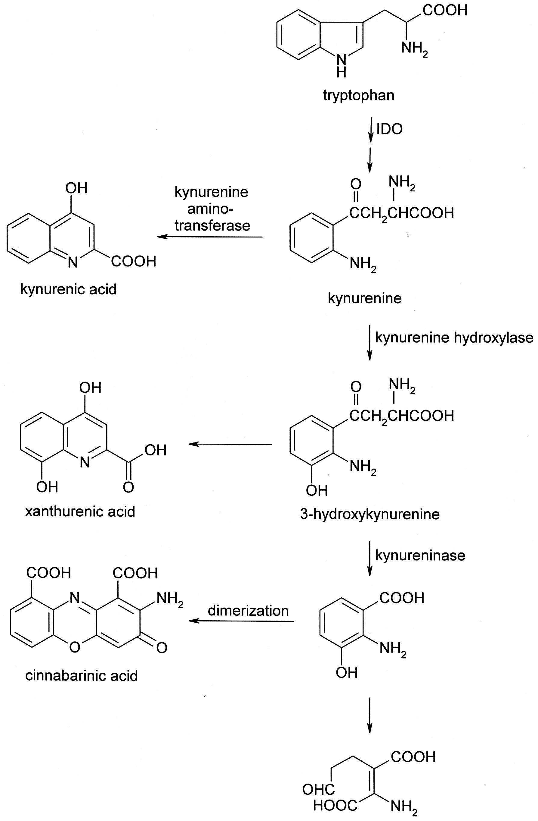
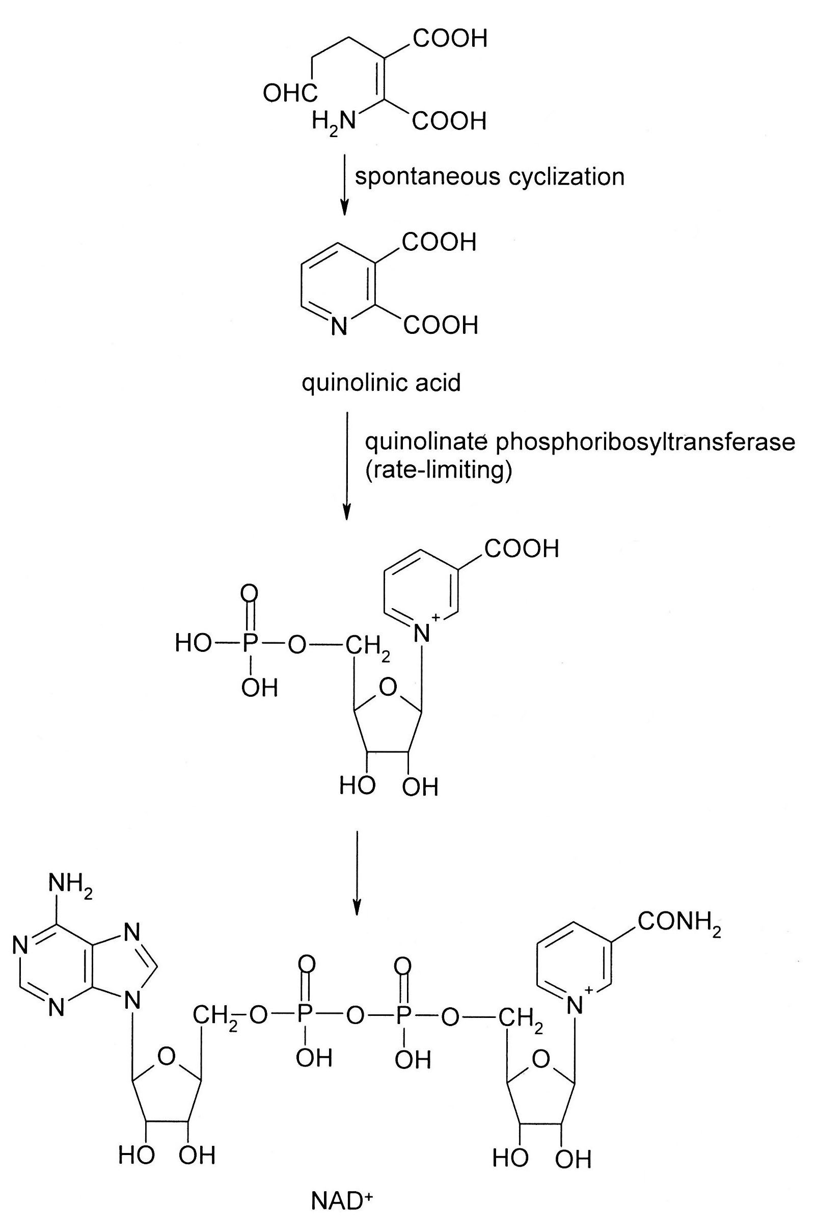

Fig. 5-19. An Abbreviated Scheme for the Degradation of Tryptophan with Emphasis on the Active Metabolites Produced.

Prostaglandin E₂ (PGE₂), which suppresses the immune response, induces IDO (Fig. 5-20). TGFβ, which provokes immune tolerance, also induces IDO, but does so indirectly via the interferons (IFNs). Specifically, TGFβ triggers the tyrosine phosphorylation of IDO via the STK, Fyn. This phosphotyrosine will bind and sequester a phosphotyrosine phosphatase; this results in phosphotyrosine having a longer half-life on proteins, such as Src, another STK. Src then phosphorylates and activates a kinase (IKKα), which in turn phosphorylates IκB and targets it for ubiquination and destruction. IκB normally inhibits the transcription factor NF-κB, which induces stress-response genes, including the IFNs. With IκB gone, NF-κB is free to transcribe the IFN genes: IFNγ further induces IDO leading to a positive feedback loop, while IFNα and IFNβ induce TGFβ. Interleukin 6 is proinflammatory and neutralizes IDO by inducing suppressor of cytokine signaling 3 (SOCS3). Like SHP, SOCS has a phosphotyrosine binding domain through which it binds IDO. SOCS3 then recruits an E3 ligase that ubiquinates IDO in preparation for its destruction.

Fig. 5-20. The Regulation of Indoleamine 2,3-Dioxygenase. Abbreviations: AHR, aryl hydrocarbon receptor; Fyn, a soluble tyrosine kinase; IκB, inhibitor of NF-κB; IKKα, IκB kinase α; IL-6, interleukin-6; IFNs, interferons; NAS, N-acetyl-5-hydroxytryptamine; NF-κB, nuclear factor transcribing the κ genes in B lymphocytes; SHP, an SH2 domain-containing phosphotyrosine phosphatase; SOCS3, suppressor of cytokine signaling 3; TGFβ, transforming growth factor β; Trp, tryptophan.

As the rate-limiting step in tryptophan destruction, IDO is also regulated by tryptophan levels. IDO has a heme whose iron must be reduced to the ferrous state for activity. IDO has both peroxidase and dioxygenase activities; in the absence of substrate, it uses peroxide to oxidize its iron and inactivate itself. When tryptophan is present, the amino acid acts as a cosubstrate wherein it is oxidized to oxindolylalanine and kynurenine while the ferric ion is reduced to ferrous and the IDO is activated. In addition to tryptophan, N-acetyl-5-hydroxytryptamine (or N-acetylserotonin, NAS) can allosterically activate IDO. NAS is a signaling molecule that suppresses inflammation by stimulating IDO and kynurenine production.

There is one final aspect of IDO: it moonlights as a nitrite reductase during hypoxia. When oxygen levels are low, it generates NO for vasodilation.

In addition to immunosuppression, kynurenine is deposited in the lens where it acts as a UV filter. Unfortunately, in time kynurenine can react with the side-chains of lysine, histidine, and cysteine in proteins, leading to the formation of cataracts. Kynurenine aminotransferase 1 (KAT1) converts kynurenine to kynurenic acid (Fig. 5-19; Table 1). Kynurenic acid is a glutamate (nicotine) antagonist; glutamate is a major excitatory neurotransmitters in the brain. Insulin levels rise with age and induce KAT1; the resulting kynurenic acid iterferes with learning and memory. In nematodes, dietary restrictions reduce kynurenic acid and improve learning and memory. On the other hand, kynurenic acid may be beneficial in stroke. In stroke, there is impairment in the delivery of oxygen to the brain, resulting in a deficiency of ATP. Stroke also leads to the release of glutamate, hyperstimulation of the brain, and unnecessary consumption of precious energy reserves. Trials of kynurenine 3-monooxygenase (also called kynurenine hydroxylase) inhibitors show promise in the treatment of stroke. By blocking the further metabolism of kynurenine, it backs up and is shifted into kynurenic acid, which inhibits glutamate receptors, thereby minimizing damage due to overexcitation. Finally, kynurenic acid binds and activates GPR35, a member of the G protein-coupled receptor family. This interaction is believed to mediate lipolysis, and other diabetogenic effects.

Table 1. A List of Active Tryptophan Metabolites and their Postulated Functions
Kynurenine | Immunosuppressant  UV filter in lens
Kynurenic acid | Glutamate (nicotine) antagonist  Diabetogenic
Xanthurenic acid | Glutamate (mGluR) antagonist  Diabetogenic  May contribute to immunosuppression
Cinnabarinic acid | Glutamate (mGlu4R) agonist
Quinolinic acid | Excitotoxin secreted by macrophages and microglia during  inflammation  Glutamate (NMDA) agonist
NAD⁺ | Coenzyme used to ferry hydrogens

Xanthurenic acid is also a glutamate antagonist, but at a different isoreceptor. It may contribute to immunosuppression by interfering with the synthesis of tetrahydrobiopterin, a coenzyme required by several enzymes responsible for the generation of inflammatory molecules. Finally, it decreases insulin secretion and activity, possibly by complexing with this hormone and by inducing the apoptosis of pancreatic cells.

3. Amino Acid Derivatives: After discussing the metabolism of amino acids, most biochemistry texts will cover amino acid derivatives: inevitably neurotransmitters, hormones and polyamines. The reader is referred to these texts for this coverage, which is quite good. However, they often neglect the topic of regulation, especially for polyamines. In addition to discussing polyamine regulation, this supplement will also examine the role of amino acids in the synthesis of coenzymes.

a. Polyamine Regulation: A brief summary of polyamine synthesis is shown in Fig. 5-21. It was noted during the discussion of the urea cycle above that ornithine could be used to synthesize polyamines and ornithine decarboxylase produces the first one, putrescine. SAM, which most readers will be familiar with as a methyl donor, is a hybrid molecule of adenosine and methionine. However, instead of the terminal methyl group being donated, it is the alkyl chain that will be transferred to form subsequent polyamines. First, SAM is decarboxylated and the resulting aminopropyl group is added to one side of putrescine to generate spermidine; the addition of a second aminopropyl group to the other side produces spermine.

Fig. 5-21. An Abbreviated Scheme for the Synthesis and Regulation of Polyamines. Note: the feedback shown for spermine actually exists for all polyamines with increasing potency for longer chains: i.e., spermine has the strongest effect and putrescine, the weakest. For that reason and to keep the figure uncluttered, only the effects of spermine are shown. Abbreviations: ODC, ornithine decarboxylase; SAMDC, SAM (S-adenosylmethionine) decarboxylase.

ODC is the committed step and SAM decarboxylase (SAMDC) generates a product that has no function outside of polyamine synthesis; as such, both enzymes are tightly regulated. SAMDC has an obligatory requirement for putrescine; after all, if there is no putrescine to accept the aminopropyl group from decarboxylated SAM, then there is no need for decarboxylated SAM, especially when there is no other use for it. Second, an accumulation of spermine will feedback to inhibit the enzyme allosterically. Polyamines can also bind to a GC-rich region in 5' end of SAMDC mRNA and inhibit its translation. Finally, mTOR is normally elevated during active growth, which requires polyamines. mTOR phosphorylation of SAMDC prolongs its half-life, which results in greater polyamine production.

ODC is tightly regulated at all levels. First, ODC is induced by mitogens, such as growth hormone and estrogens. Second, translation of ODC mRNA is inhibited by polyamines (negative feedback). Like SAMDC mRNA, ODC mRNA has a GC-rich region, but it is not known if this is the site where polyamines act. It should be noted that all polyamines have this and other effects described below, but they differ in their potency. In general, the longer the chain, the more potent the effect: i.e., spermine is the most potent and putrescine, the weakest.

Finally, polyamines elevate the cellular levels of an ODC antizyme. ODC antizyme binds to and inhibits ODC. It also triggers the degradation of ODC by the proteasome, although this does not involve ODC ubiquination. The antizyme has other effects that reduce polyamine levels and inhibit proliferation; e.g., it inhibits polyamine transport into the cell and triggers the ubiquination of cyclin D1, the regulatory subunit of several cycle-dependent kinases required for mitosis. Polyamines elevate ODC antizyme in two ways; the first is dependent on frameshifting. ODC antizyme has a stop codon at position 36; as such, one would never expect it to be synthesized. However, polyamines induce a translational frameshift that allows the ribosome to read through the stop codon. Second, polyamines block the ubiquination and degradation of the antizyme, presumably by direct binding to the protein. Interestingly, there is yet another level of regulation: there is an inhibitor of the inhibitor. The ODC antizyme inhibitor is homologous to ODC but lacks any ODC enzymatic activity; and it binds more tightly to the antizyme than ODC itself. As such, it is an effective decoy that can rescue ODC from the antizyme. Artificial manipulation of the concentration of the antizyme inhibitor has dramatic effects on polyamine levels and mitosis; but how the inhibitor might be physiologically regulated is not yet known. Finally, peptidyl arginine deiminase 4, which is associated with growth and frequently elevated in cancers, deiminates (converts an arginine to a citrulline) the antizyme, thereby inhibiting it and elevating polyamine levels.

There is also a way to clear excess polyamines: acetylation inactivates polyamines. Polyamines increase the half-life of the mRNA for the polyamine acetyltransferase. As a result, more acetyltransferase is translated and more polyamines can be inactivated.

b. Coenzymes: Amino acids also play an essential role in the synthesis of coenzymes. Because coenzymes are critical to intermediary metabolism, their origins and synthesis are introduced here. A comprehensive discussion of coenzyme synthesis is outside the scope of this supplement, but sufficient information will be provided to give the reader an appreciation for the link between amino acids and coenzymes.

Fig. 5-22 dissects several coenzymes in order to see the components contributed by amino acids. Thiamine is a conjugation of a pyrimidine and a thiazole. As will be seen in the next section, pyrimidines are made from aspartate and carbamoyl phosphate, while the thiazole is made from a sugar, a glycine derivative, and the sulfur from cysteine. Tocopherol is synthesized from a tyrosine metabolite and a phytol side-chain. The biotin rings are composed of alanine and the sulfur from cysteine. The origin of the side-chain is interesting: malonyl CoA is methylated to trick the FAS into condensing it with malonyl CoA. After one more condensation and a demethylation, the dicarboxylic acid, pimelic acid, is formed. Folic acid has three components: the pterin ring is made from guanine. Again, as will be seen in the next section, purines are synthesized in part from glycine. The p-aminobenozoic acid is synthesized from chorismate,a precursor to the aromatic amino acids. A polyglutamate tail helps to keep the folic acid from leaving the cell.

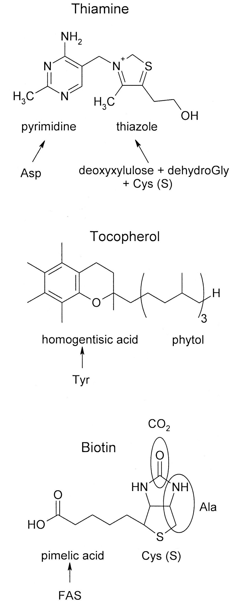

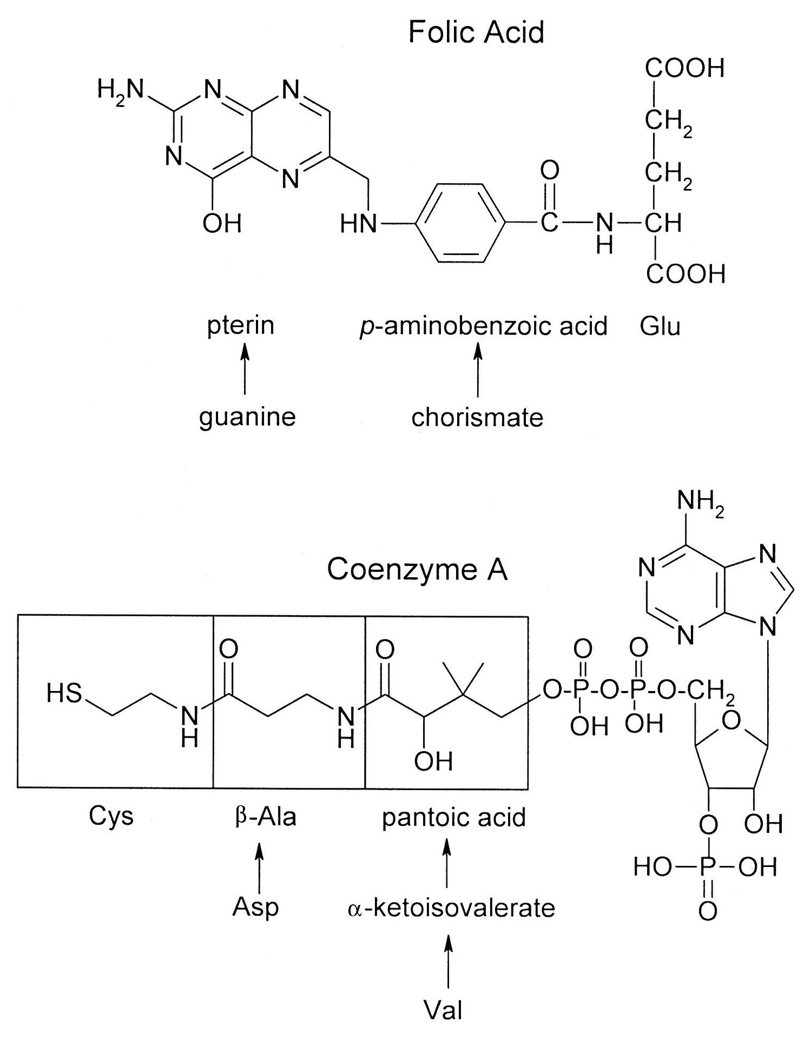
Fig. 5-22. Several Coenzymes Showing the Origins of their Structural Components.

Finally, the working chain of coenzyme A is synthesized from three amino acids: cysteine, aspartic acid and valine. Valine is transaminated, hydroxymethylated, and then reduced to form pantoic acid. Meanwhile, aspartate is decarboxylated form β-alanine and the two molecules joined head-to-tail to create pantothenate. Finally, cysteine is added to the β-alanine in a head-to-head arrangement, leading to the loss of one of the carboxyl groups. The nucleotide is added last.

Section 2: Nucleotide Metabolism
1. Purine Synthesis
a. Pathway: Purine synthesis begins with ribose phosphate pyrophosphokinase, which is the rate-limiting step in both nucleotide and protein synthesis (as noted above, PRPP is involved with both tryptophan and histidine synthesis):

ribose-5-P + ATP -> ribose-1-PP-5-P + AMP

It is upon PRPP that the purine ring will be built. The pyrophosphate primes the C1 for the next step: the pyrophosphate is displaced by the amide from glutamine. The reaction is catalyzed by amidophosphotransferase, the committed step, and driven by pyrophosphate hydrolysis. This is a common mechanism to drive reactions that would otherwise be near equilibrium: it occurs during the synthesis of UDP-glucose in glycogen synthesis and it occurs in the urea cycle during the synthesis of argininosuccinate (Fig. 5-13). Also, note that while glutamate is the usual nitrogen donor in amino acid synthesis, glutamine will be the major donor in nucleotide synthesis.

The rest of the pathway is summarized in Fig. 5-23. Briefly, a glycine is coupled to the amino group, the carbonyl undergoes transamination, a formyl group from THF is added to the terminal amino group (N7) and the ring is closed. Next, the C5 is carboxylated and the carbonyl amidated; a second formyl group is added to N3 and the second ring is closed. This gives rise to inosine monophosphate (IMP). For guanosine, C2 is oxidized so that it can be transaminated. In inosine, C6 is already oxidized; and one might assume that it can be directly transaminated to make adenosine. However, one would be wrong. Rather, the amino group comes from aspartate which temporarily forms a hybrid molecule, adenylosuccinate. The adenylosuccinate is then cleaved into adenosine and fumarate. The reader may recall that the same reactions occur in the urea cycle to form argininosuccinate. In muscle, this is a major pathway to shuttle aspartate into the TCA cycle as fumarate: the adenosine is repeatedly deaminated by the myoadenylate deaminase, recoupled to aspartate, and cleaved into fumarate. This is known as the purine nucleotide cycle. In addition to supplying fodder for the TCA cycle, the ammonia generated stimulates phosphofructokinase and glycolysis and neutralizes lactic acid and ketone bodies. The IMP stimulates glycogen phosphorylase b to mobilize even more energy; although not as potent as AMP, its levels are higher during heavy exercise. Finally, by consuming AMP, it favors the formation of ATP from ADP by the myokinase; the reaction would otherwise be near equilibrium:

myokinase
ADP + ADP <─────────> ATP + AMP

The importance of this cycle can be seen in mutations of the myoadenylate deaminase, which can lead to easy fatigability, muscle cramps and myalgias due to energy deficiency. A summary of the origins of the atoms in purines is shown in Fig. 5-24.

Fig. 5-23. An Abbreviated Synthetic Pathway for Purines.

Fig. 5-24. Origin of the Atoms in Purine Nucleotides.

b. Regulation: Regulation of purine synthesis begins with the purinosome, the metabolon containing all of the enzymes for purine synthesis. First, two of the proteins have multiple enzymatic activities: GART (phosphoribosylglycinamide synthetase/phosphoribosylglycinamide formyltransferase/ phosphoribosylaminoimidazole synthetase) adds glycine, the first formyl group and closes the ring; and PAICS (phosphoribosylaminoimidazole carboxylase/ phosphoribosylaminoimidazole succinocarboxyamide synthetase) adds the second formyl group and closes the second ring. The first three enzymes (amidophosphotransferase, GART and formylglycinamidine ribonucleotide synthase or FGAMS) form the core of the purinosome with the other enzymes located peripherally. This is not a permanent structure; it can be reversibly assembled to match the nucleotide needs of the cell. For example, casein kinase 2 (CK2) can phosphorylate all three core enzymes and cause them to dissociate. However, some mitogens act through G protein-coupled receptors (GPCR) coupled to G_{i}, which inhibits CK2 via an unknown pathway. The purinosome can then reform to make purines for DNA synthesis. Other mitogens, like EGF and Ras, stimulate MAPK, which phosphorylates FGAMS and leads to increased purine production. Purine depletion induces ASB11, an adaptor for ubiquitin ligase that targets PAICS for modification (see Unit 1 for a discussion of ubiquitination). This attracts an ubiquitin-associated protein 2 (UBAP2), which possesses IDRs and triggers the formation of purinosomes via phase separation. Epinephrine through a pathway involving mTOR induces purinosome-mitochondrial association; the latter supplies energy, aspartate, glutamine, glyine, and one-carbon units for purine synthesis. mTOR acting through the transcription factor, ATF4, also induces methyleneTHF dehydrogenase 2, the enzyme that oxidizes methyleneTHF to formylTHF; formylTHF is needed at two steps in purine synthesis. Finally, AMPK triggers the self-association of FGAMS, which disrupts the purinosome. Purine synthesis requires 5 ATP/purine; if energy levels are low, AMPK is active and shuts down purine synthesis to conserve energy.

The regulation of the individual enzymes is shown in Fig. 5-25. All the nucleotides exert feedback inhibition to the amidophosphotransferase; ADP and GDP also inhibit ribose phosphate pyrophosphokinase. More specific control is accomplished by AMP and GMP inhibiting the branch point leading to ATP and GTP, respectively. Finally, there is cross-regulation: ATP and GTP stimulate each other’s synthesis. This insures that the synthesis of each purine is balanced.

Fig. 5-25. The Regulation of Purine Synthesis. The first two steps are ribose phosphate pyrophosphokinase and amidophosphotransferase; the step immediately preceding the IMP is PAICS.

In addition to allosteric control, insulin, the major anabolic hormone in the body, stimulates purine synthesis at several steps. First, it induces the committed step in PPP, which produces the ribose for nucleotides. It also stimulates the amidophosphotransferase and PAICS. All these effects are mediated by PKB, but it is not known if PKB directly phosphorylates these enzymes or acts indirectly. PKB does directly phosphorylate FGAMS but the effects are unknown.

Finally, IMP dehydrogenase can be inhibited by acetylation by clock, a component of the circadian cycle; this imposes a diurnal rhythmicity to purine synthesis. Succinylation also inhibits IMP dehydrogenase and is removed by SIRT5. SIRT5 is responsible for metabolic reprogramming the cell to support proliferation and its reactivation of IMP dehydrogenase would complement this reprogramming. In the retina, a large amount of GTP is needed for cGMP signaling in the presence of light. In the dark, IMP dehydrogenase is phosphorylated, rendering it more sensitive to GTP feedback inhibition and lowering GTP levels when it is not needed. The identity of the kinase and its linkage to light is not known.

2. Pyrimidine Synthesis
a. Pathway: The pathway for pyrimidine synthesis is depicted in Fig. 5-26. Briefly, carbamoyl phosphate condenses with aspartate and the ring is closed. A double bond is introduced at C5-C6, phosphoribose from PRPP is added to N1, and the carbonyl on C6 is lost as CO₂. This generates UMP. To make CTP, UMP is phosphorylated up to UTP and the carbonyl at C4 is transaminated. The synthesis of thymidine presents a little problem. It is only found in DNA and, therefore, must be coupled to deoxyribose. If the ribose on UTP is reduced first, dUTP could be incorporated into DNA; if instead UTP is methylated first, TTP could be incorporated into RNA. The solution is based on the fact that both DNA and RNA polymerases exclusively use nucleotide triphosphates. Therefore, the ribose is reduced on UDP, which is further dephosphorylated before being methylated. dTMP can then be safely rephosphorylated to dTTP. The methyl group is added by thymidylate synthetase. N⁵,N¹⁰-Methylene THF donates the methyl group and is regenerated by dihydrofolate reductase, which forms a tight complex with the thymidylate synthetase. This enzyme can also be stimulated by O-GlcNAcylation, which in turn, is driven by glucose levels. Essentially, abundant energy and glycolytic products favors growth. A summary of the origins of the atoms in purines is shown in Fig. 5-27.

Fig. 5-26. An Abbreviated Synthetic Pathway for Pyrimidines.

Fig. 5-27. Origin of the Atoms in Pyrimidine Nucleotides.

b. Regulation: As with purine synthesis, regulation begins with the metabolon. In bacteria and plants, the first three enzymes are separate but form a multienzyme complex. In animals and fungi, these enzymes are fused and known CAD (Carbamoyl phosphate synthetase (CPSase), Aspartate transcarbamoylase (ATCase), and Dihydroorotase). In prokaryotes, CPSase is actually three enzymes in one: there are three catalytic sites separated by two tunnels that transport unstable intermediates. The first catalytic site generates ammonia from glutamine:

Gln + H₂O ───> Glu + NH₃

As such, this is a different isozyme than that in the urea cycle; the latter uses free ammonia rather than generating it. The ammonia is transferred by the ammonia tunnel to the second catalytic site, where it is combined with bicarbonate to form carbamate:

HCO₃⁻ + ATP ───> carboxy PO₄
carboxy PO₄ + NH₃ ───> carbamate (H₂NCOO⁻)

The carbamate is then transferred by the carbamate tunnel to the third catalytic site where it is activated by ATP to form carbamoyl phosphate:

carbamate + ATP ───> carbamoyl PO₄

CPSase is the rate-limiting step and is highly regulated in animals (Fig. 5-28). UDP, UTP, and CTP all allosterically inhibit it (feedback inhibition), while PRPP stimulates it (feed forward). CPSase can also be phosphorylated: mitogens, acting through MAPK, stimulate the enzyme by increasing its sensitivity to PRPP (an activator) and decreasing its sensitivity to UTP; and PKA phosphorylation decreases its sensitivity to UTP. In the fed state mTOR initiates a protein kinase cascade that leads to S6KI phosphorylation of CPSase; this promotes the assembly and enzymatic activity of CPSase. Rheb is a G protein that activates mTOR; however, it also has other targets and can directly bind and activate CAD. Finally, CAD can be induced. Estradiol is mitogenic for many reproductive tissues and stimulates the transcription of CAD. There may be some cross-talk between purine and pyrimidine synthesis: FGAMShas been shown to associate with CAD; but the significance of this observation is unknown.

Fig. 5-28. The Regulation of Pyrimidine Synthesis in E. coli and Animals. Abbreviations: ATCase, aspartate transcarbamoylase; CPSase, carbamoyl phosphate synthetase; E₂, estradiol.

ATCase is the committed step and is the major target of prokaryotic regulation: ATP allosterically stimulates ATCase (adequate energy is available for synthesis), while CTP inhibits it (feedback inhibition).

The last two enzymes in UMP synthesis (orotate phosphoribosyltransferase and orotidylate decarboxylase) are also fused in animals and often simply called UMP synthetase. Although separate in lower organisms, they usually exist in a single complex.

CTP synthetase is the rate-limiting step in CTP synthesis and is highly regulated, since the CTP pool is the smallest due to the fact that it is used for both nucleotide and phosphatidylcholine synthesis. CTP exerts feedback inhibition; and both PKA and PKC phosphorylation stimulate the enzyme by reducing this CTP product inhibition. CTP synthetase is also allosterically stimulated by ATP, UTP and GTP, probably to keep the nucleotide ratios appropriate. Finally, it is indirectly stimulated by insulin: GSK3 phosphorylates and inhibits the enzyme; insulin, through PKB, phosphorylates and inhibits GSK3. By inhibiting the inhibitor, insulin stimulates CTP synthetase.

IMP dehydrogenase and CTP synthetase also form filaments, called cytoophidia (cf. acetyl CoA carboxylase in fatty acid synthesis). The literature is conflicting on the activity and function of these structures. Some authorities claim that IMP dehydrogenase is inactive in filaments, which may act as a reservoir. Similarly, in Drosophila, starvation and apoptosis, conditions antagonistic to growth, cause the cytoophidia of CTP synthetase to expand. Furthermore, in this species cytoophidia prolong the half-life of CTP synthetase, an effect consistent with a reservior function. However, other authorities report that calcium, Ras and mTOR, normally associated with growth, stimulate filament formation and some of these factors also enhance enzyme activity, while GNP inhibits formation and activity. They further propose that filaments may enhance allosterism or act as a platform for other enzymes. In part, the confusion may be due to species specificity, multiple filamentous forms, nonenzymatic effects, or an indirect role this assembly has on activity: e.g., in fungi, cytoophidia are unresponsive to nucleotide feedback inhibition. In bacteria, CTP induces filament formation of CTP synthetase and enzyme inhibition, as might be expected in feedback inhibition. However, in humans UTP stimulates filament formation and CTP synthetase activity (feed forward), while nutrient depletion suppresses IMP dehydrogenase activity via filament formation.

Finally, pyrimidine synthesis is coordinated with glycolysis. Specifically, CAD can act as a deamidase toward RelA, a transcription factor that normally induces genes involved with inflammation. However, deamidated RelA triggers the transcription of genes promoting glycolysis. Glycolytic intermediates can then be used in pyrimidine synthesis. As noted above, thymidine synthetase is stimulated by O-GlcNAcylation. This modification is driven by glucose levels, which in turn, signals abundant substate for glycolysis.

3. Deoxynucleotide Synthesis: The ribonucleotide reductase (RNR) is responsible for the conversion of all ribonucleotides to deoxyribonucleotides. Which ribonucleotide gets converted depends upon a delicate balance between positive and negative allosteric effects of the enzyme products. The reader is referred to any standard biochemistry textbook for the details. This supplement will only consider the rationale for such tight regulation and discuss several other types of regulation not usually covered in standard textbooks.

Every student from high school through college is taught that dC pairs with dG and dT pairs with dA. This is based on the creation of bonds between these pairs and the decrease in free energy that occurs with the formation of these bonds. However, all thermodynamics is statistics: dC can form bonds with dA and dT, with dG; but they do not decrease the free energy as much as the "perfect" match. The difference, however, is not as much as the student may expect: -4.5-5.5 kcal/mol for the perfect match and -1.5-2.5 kcal/mol for the imperfect match. A high concentration of a dNTP can compensate for the lower affinity of a mismatch, which can lead to mutations. In addition, pathologically elevated deoxyribonucleotides can have other deleterious effects. For example, loss-of-function mutations of cytidine deaminase elevate dCTP levels which inhibit poly(ADP-ribose) polymerase 1 (PARP-1), an enzyme required to replicate some difficult to replicate loci. As a result, DNA replication is incomplete. Therefore, a proper balance among the dNTPs not only increases efficiency, but it also reduces mutations and other adverse effects.

In addition to allosteric regulation by nucleotides, RNR is subject to posttranslational modifications. ATM is a kinase previous introduced in the section on the PPP; it is activated during stress, including DNA damage. ATM phosphorylation of RNR stabilizes it; this will enhance dNTP production which will be needed during DNA repair. On the other hand, NO inhibits RNR. In this case, rather than reacting with cysteines, NO reacts with a tyrosine required for catalysis. NO is generated during microbial infection and may inhibit DNA synthesis in the microorganism. In yeast, RNR can be regulated by compartmentalization. Dif1 is a protein that sequesters the small subunit in the nucleus. Iron is required for DNA repair enzymes and iron deficiency can lead to DNA damage, whose repair will require dNTPs. Iron deficiency activates the kinase, Dun1, which phosphorylates Dif1 and releases the small subunit. The small subunit migrates to the cytoplasm, joins with the large subunit and the holoenzyme synthesizes dNTPs.

Spd1, the mammalian counterpart of Dif1, can also be neutralized by degradation. PCNA (proliferating cell nuclear antigen) is a processivity factor for DNA polymerase δ during DNA synthesis and repair. PCNA binding to DNA triggers the ubiquination and degradation of Spd1, resulting in dNTP production for DNA synthesis or repair. Finally, RNR can be induced: e.g., progesterone stimulates the proliferation of the uterine lining and induces RNR to support this growth.

4. Nucleotide Catabolism
a. Salvage Pathway: Most basic biochemistry textbooks cover the purine salvage pathway (q.v.), but never mention the pyrimidine salvage pathway. First, cytosine is converted to uracil by deamination, then coupled to ribose-1-phosphate by uridine phosphorylase, and finally phosphorylated to UMP:

The uridine kinase is the rate-limiting step. It is stimulated by phosphorylation by ATR (ataxia telangiectasia and Rad3 related), a member of the ATM kinase family; and like ATM, it is activated in response to DNA damage and ionizing radiation. Thymine is recycled in a similar manner: thymidine phosphorylase couples thymine to deoxyribose-1-P to make thymidine, which is then phosphorylated by thymidylate kinase.

b. Purine Catabolism: An abbreviated pathway for purine catabolism is shown in Fig. 5-29. Briefly, the purines are stripped of their phosphate, sugar and amino groups. Guanidine yields xanthine, but adenosine yields hypoxanthine, which is converted to xanthine by a subsequent oxidation. A final oxidation on C8 converts xanthine to uric acid, the final excretion product in reptiles, birds, and hominoid apes. Plants and other animals continue to break uric acid down into simpler compounds (Fig. 5-30). Basically, the rings are open via further oxidation and the ends nibbled away, producing ureidoglycolate and urea in animals and glyoxylate, carbon dioxide, and ammonia in plants. The first step to this further degradation is urate oxidase. When animals became committed to dry land (reptiles and birds), they lost the urate oxidase. On dry land, water is not always readily available and body water needs to be conserved. Soluble excretory products are osmotically active and draw water out of the body. Uric acid is sparingly soluble in water and precipitates at high concentrations; as such, reptiles and birds excrete a paste, which saves valuable water. There was no problem with the obstruction of excretory ducts as these animals have a single large passage (the cloaca) that serves the excretory, digestive, and reproductive systems. However, with the advent of mammals, this changed and the low solubility of uric acid became a liability. At this point, urate oxidase was reacquired but lost a second time in the hominoid apes. This loss has led to the development of precipitates in kidneys (urate stones) and joints (gout) in susceptible individuals. Such individuals are often treated with allopurinol, a competitive inhibitor of xanthine oxidase. This drug blocks the formation of uric acid, thereby keeping levels low. One would assume from this pathology that the second loss of urate oxidase was a sudden, unfortunate event. However, because the loss occurred gradually and was accompanied by an increase in affinity of the renal urate transporter that resorbs uric acid, it has been concluded that elevated uric acid levels conferred some advantage to hominoid apes and was selected for.

Fig. 5-29. An Abbreviated Scheme for the Degradation of Purines. Although only ribonucleotides are shown, the 5’nucleotidase removes either ribose or deoxyribose.

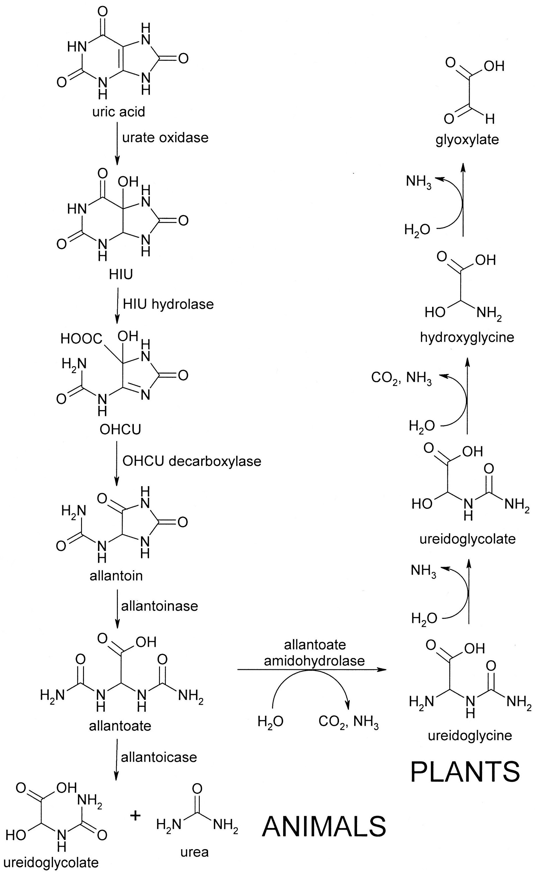
Fig. 5-30. An Abbreviated Scheme for the Degradation of Uric Acid in Plants and Lower Animals.

Many hypotheses have been proposed to explain this second loss of urate oxidase. One hypothesis is based on the observation that urate oxidase was lost at the same time that hominoid apes lost the ability to synthesize vitamin C. Both molecules are antioxidants; as such, uric acid is envisioned as a replacement for the antioxidant function of vitamin C. This would correspond nicely with the regulation of xanthine oxidoreductase, which catalyzes the equilibrium between xanthine and uric acid. The enzyme has a disulfide bond; when oxidized, the enzyme favors oxidation. That is, an oxidizing environment enhances to formation of uric acid, an antioxidant.

Other hypotheses are based on the structural similarity of uric acid with caffeine. It has been proposed that uric acid enhances cognitive abilities or that it maintains blood pressure during salt deficiency. Another hypothesis is based on the fact that uric acid released during cell injury initiates an inflammatory reaction (e.g., in gout). This suggests that uric acid may act as an endogenous adjuvant.

The most recent hypothesis is based on the finding that the slow loss of urate oxidase coincides with a shift in the world’s environment from tropical to temperate with the subsequent spread of fruit trees. Uric acid is envisioned as facilitating the assimilation of fructose into triglycerides (Fig. 5-31). As noted in Unit 3, fructose is converted to fructose-1-phosphate by ketohexokinase after cellular uptake. Aldolase B then split the sugar into DHP and glyceraldehyde without going through PFK1 and its negative feedback regulation. DHP can form glycerol for the triglyceride backbone and glyceraldehyde forms pyruvate, which is oxidatively decarboxylated to acetyl CoA in the mitochondria. Acetyl CoA couples with OAA to form citrate; but uric acid inhibits aconitase. Therefore, the citrate shuttles the acetyl CoA into the cytoplasm for fatty acid synthesis.

Fig. 5-31. An Illustration of the Hypothesis Relating the Loss of Urate Oxidase to the Acquisition of a Fructose-Rich Diet.

In addition to the regulation of xanthine oxidoreductase by oxidation of its disulfide bonds described above, purine catabolism has other regulatory loci. Urate oxidase is inhibited by acetylation. Presumably, if acetyl CoA is elevated, energy and materials are abundant and growth, not catabolism, is favored. Finally, the AMP deaminase in the purine nucleotide cycle (Fig. 5-23) is stimulated by muscle contraction, NDP and NMP, and inhibited by NTP. That is, it is active when energy is needed and inhibited when energy is abundant. In the former situation, the cycle shuttles amino acids into the TCA cycle.

c. Pyrimidine Catabolism: The catabolism of pyrimidines is shown in Fig. 5-32. Briefly, the phosphate and sugar are removed, deamination follows if appropriate, the double bond is reduced and the ring opened with the loss of C2 and N3 as carbon dioxide and ammonia, respectively. This converts CMP and UMP to β-alanine and dTMP to β-aminoisobutyrate. A second transamination yields malonyl CoA and methylmalonyl CoA, respectively. The former is an intermediate in fatty acid synthesis and the latter is an intermediate in the conversion of propionyl CoA to succinyl CoA, as occurs in the catabolism of certain amino acids and of fatty acids with an odd number of carbons (q.v.).

Fig. 5-32. An Abbreviated Scheme for the Degradation of Pyrimidines.

The most studied enzymes in this pathway are dihydropyrimidine dehydrogenase, which reduces the double bond and is the rate-limiting step in pyrimidine degradation, and thymidine phosphorylase, which removes the sugar from thymidine. The latter is important as a predictor of cancer response to 5-fluorouracil (5-FU), an antineoplastic drug that is a suicide inhibitor of thymidylate synthetase. The thymidine phosphorylase reaction is at equilibrium and it can activate 5-FU by coupling it to deoxyribose to form 5-fluoro-2’-deoxyuridine. Both enzymes are regulated by gene induction but studies are conflicting: growth factors elevate the enzymes; but growth factor antagonists like antiestrogens also induce the enzymes. Perhaps nucleotide turnover may be more important in catabolic rates than growth per se.

The activation-induced deaminase (AID) is a special enzyme that converts C to U in situ. Since C pairs with G and U pairs with A, this conversion is potentially mutagenic. However, it has several important functions. When B lymphocytes are activated, their antibody genes undergo hypermutation in an attempt to increase the affinity and specificity of the antibody. In addition, hypermutation can lay the groundwork for heavy chain switching by somatic recombination. This is a process whereby exons can be spliced out of DNA. C-to-U mutations are repaired by a process that begins with removing the base. Multiple abasic nucleotides on both strands can cause dsDNA breaks which are a prelude to recombination. These mutations are also involved with gene conversions, where genes recombine with pseudogenes to increase diversity.

Nonetheless, it is still a dangerous phenomenon and may be responsible for the high incidence of B cell lymphomas. As such, AID is highly regulated. First, it only occurs in mature B cells that have been stimulated by antigens. Second, it only occurs at certain sites (A/T-Pur-C-Pyr) having a specific structure (stem loop with C at the bend) and near a mooring site that anchors AID. It occurs only on ssDNA; i.e., it is restricted to actively transcribed regions. Furthermore, AID has a very low catalytic turnover (0.25-1/min) so as the limit the “damage”. Finally, the enzyme can be regulated by phosphorylation: PKA phosphorylation stimulates AID by facilitating its binding to chromatin; but phosphorylation at the amino terminus by an unknown kinase interferes with the interaction of AID with its target sequence. PKA is activated by stress, such as antigen exposure; therefore, it is logical for it to play a role in fine-tuning the antibody response.

